**MODULE 4 LAB 1: DATABASE CONNECTIONS AND MODELS**

**IFT 544 MIDDLEWARE PROGRAMMING AND DATABASE SECURITY**

**DEEPTHA NELLORE BALAJI**

**Instructor – Prof. Dinesh Sthapit**

**10/08/2023**

**Task 1: Connecting to MongoDB Database with Mongoose:**

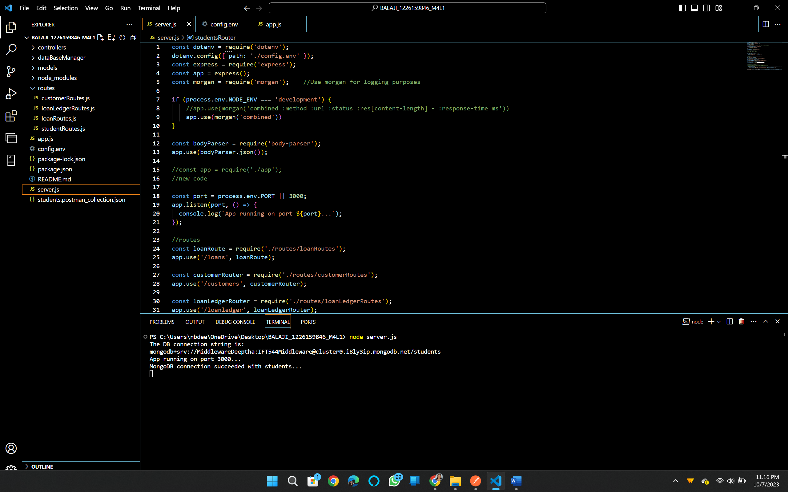

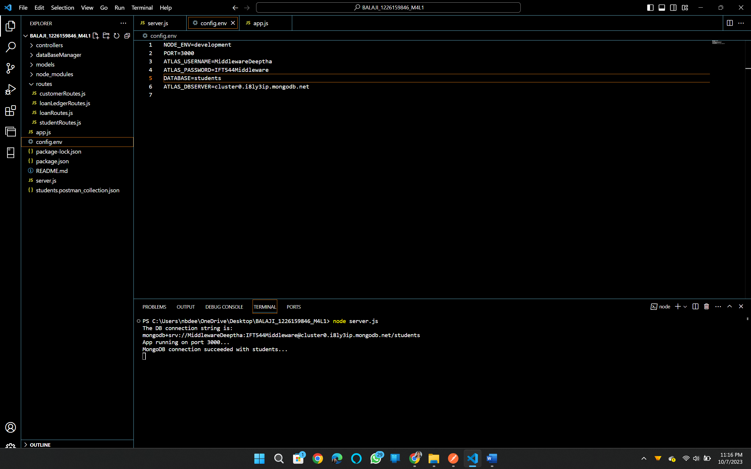

**Students database created at Mongo DB atlas**

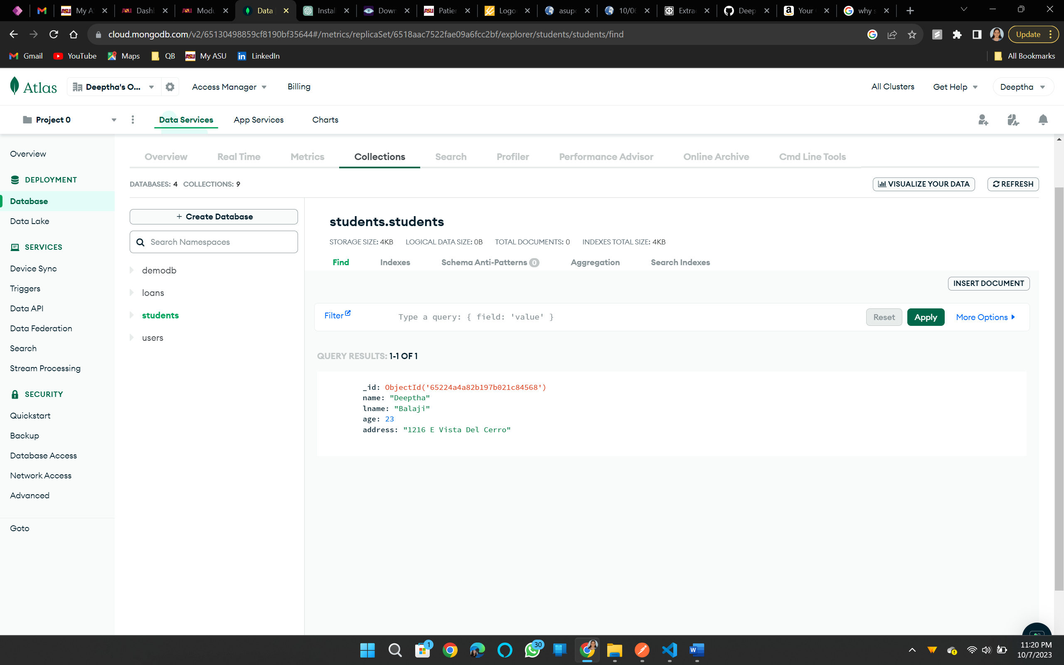

**Task 2: Creating Models in Mongoose**

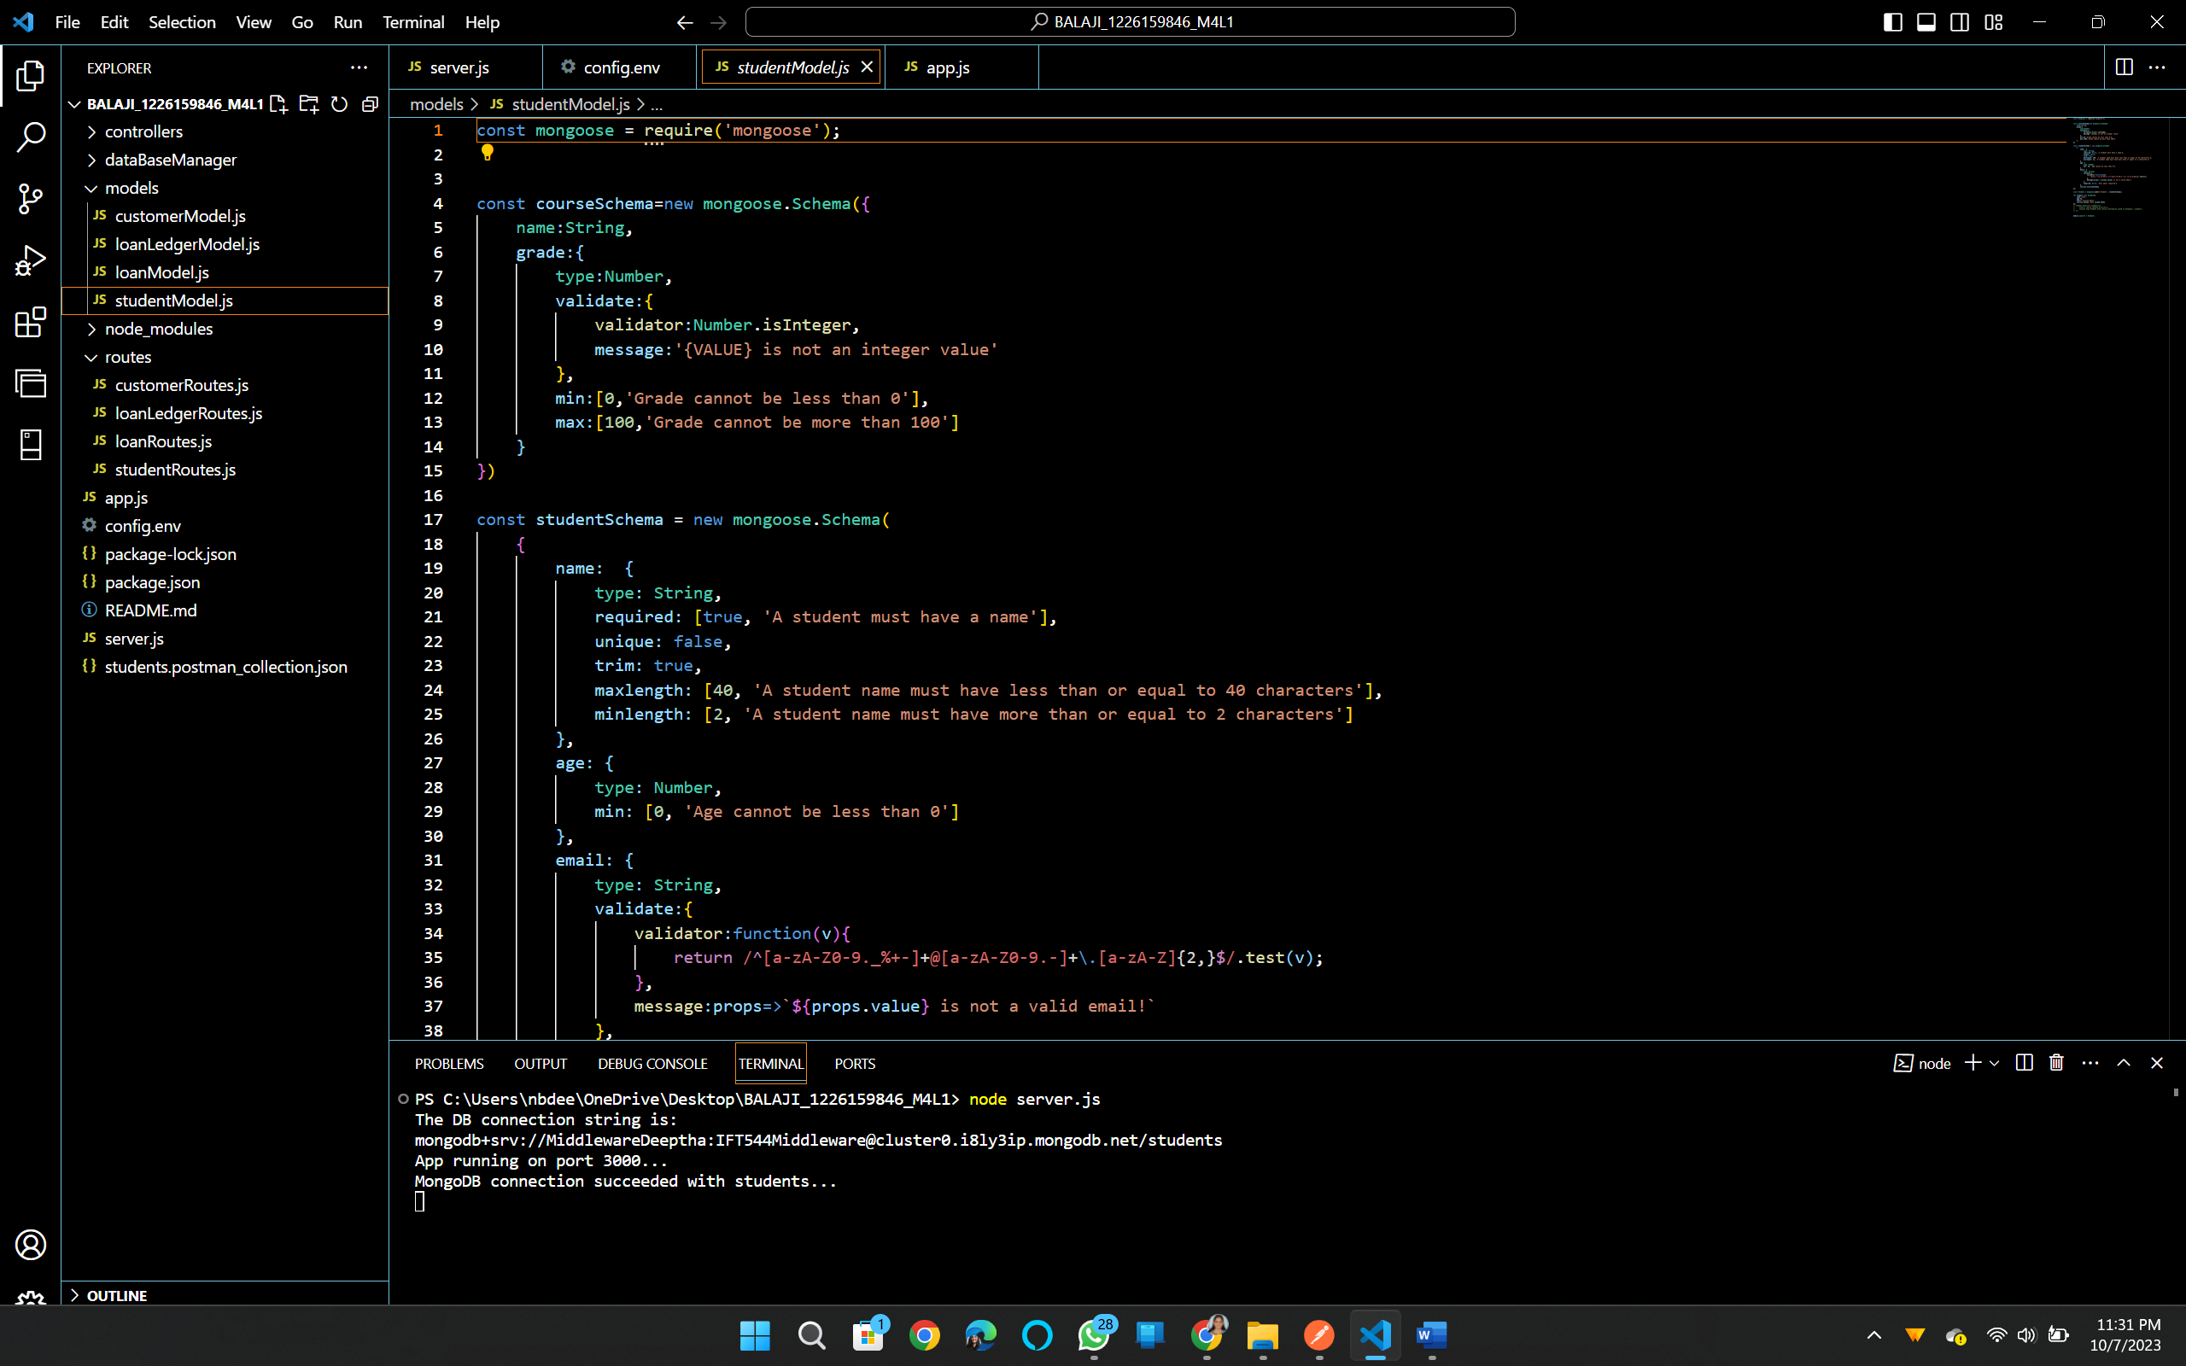

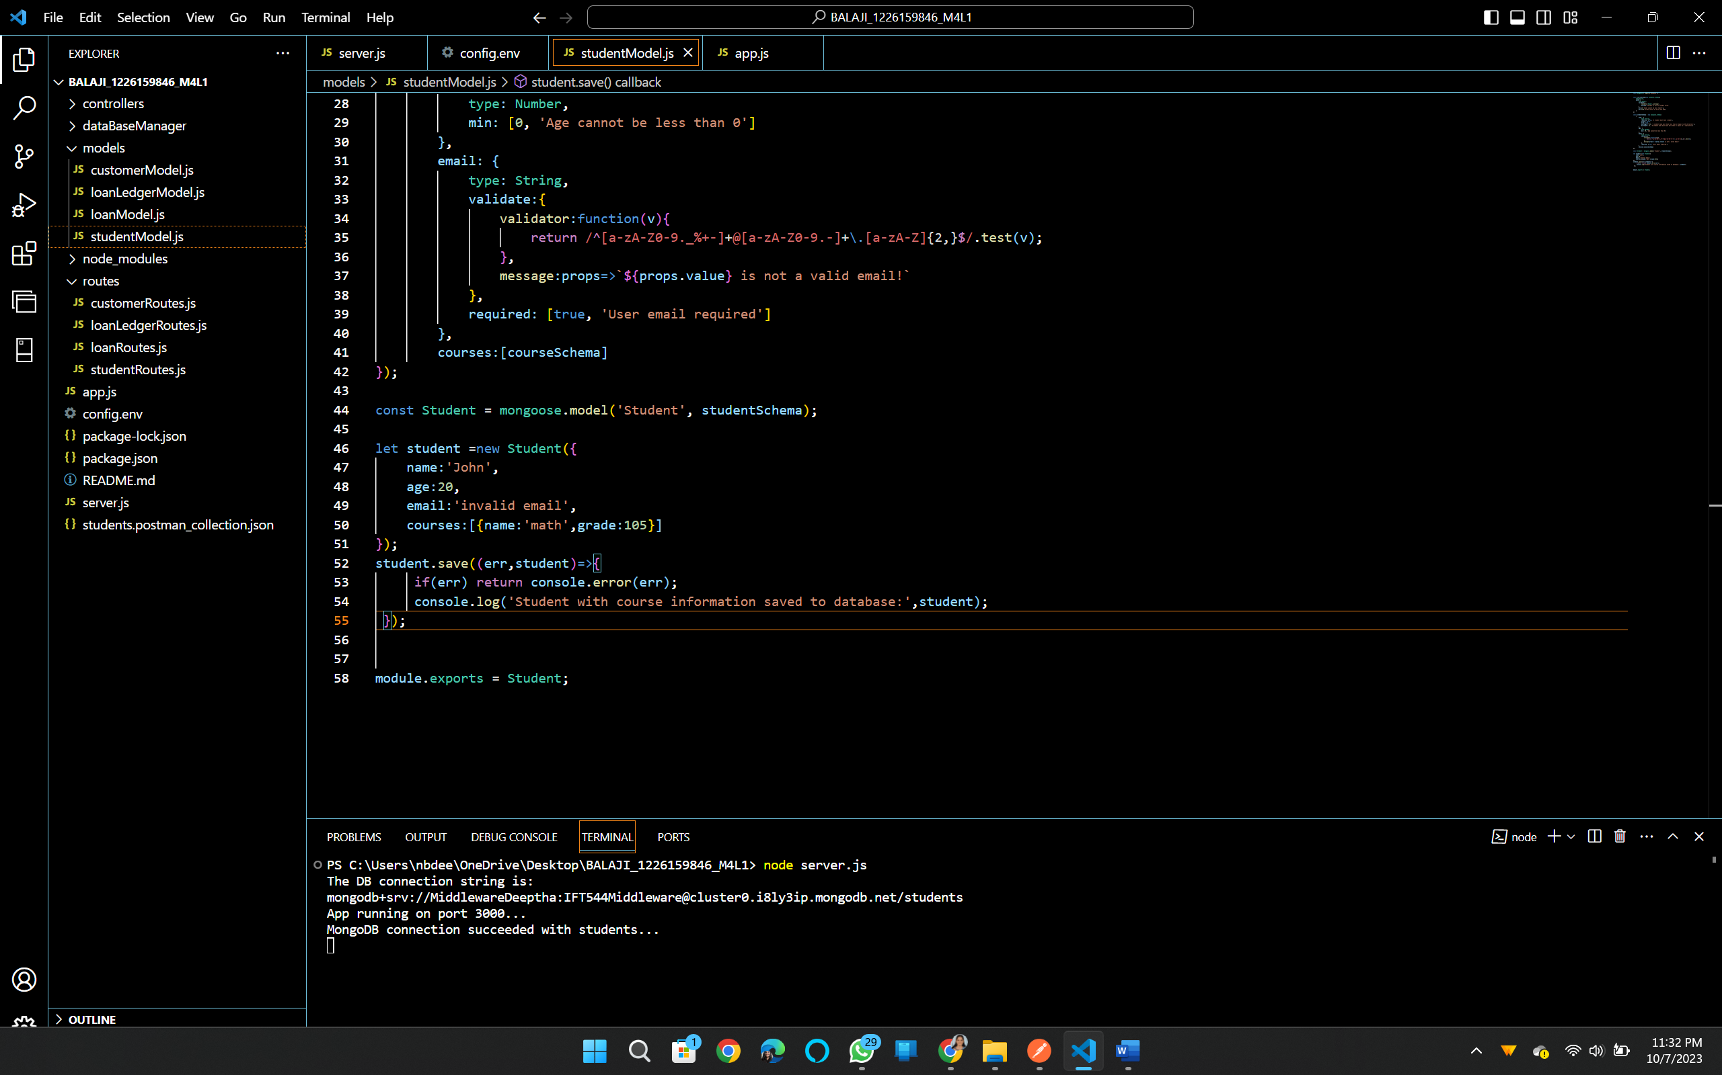

**Task 3: Extending Models in Mongoose**

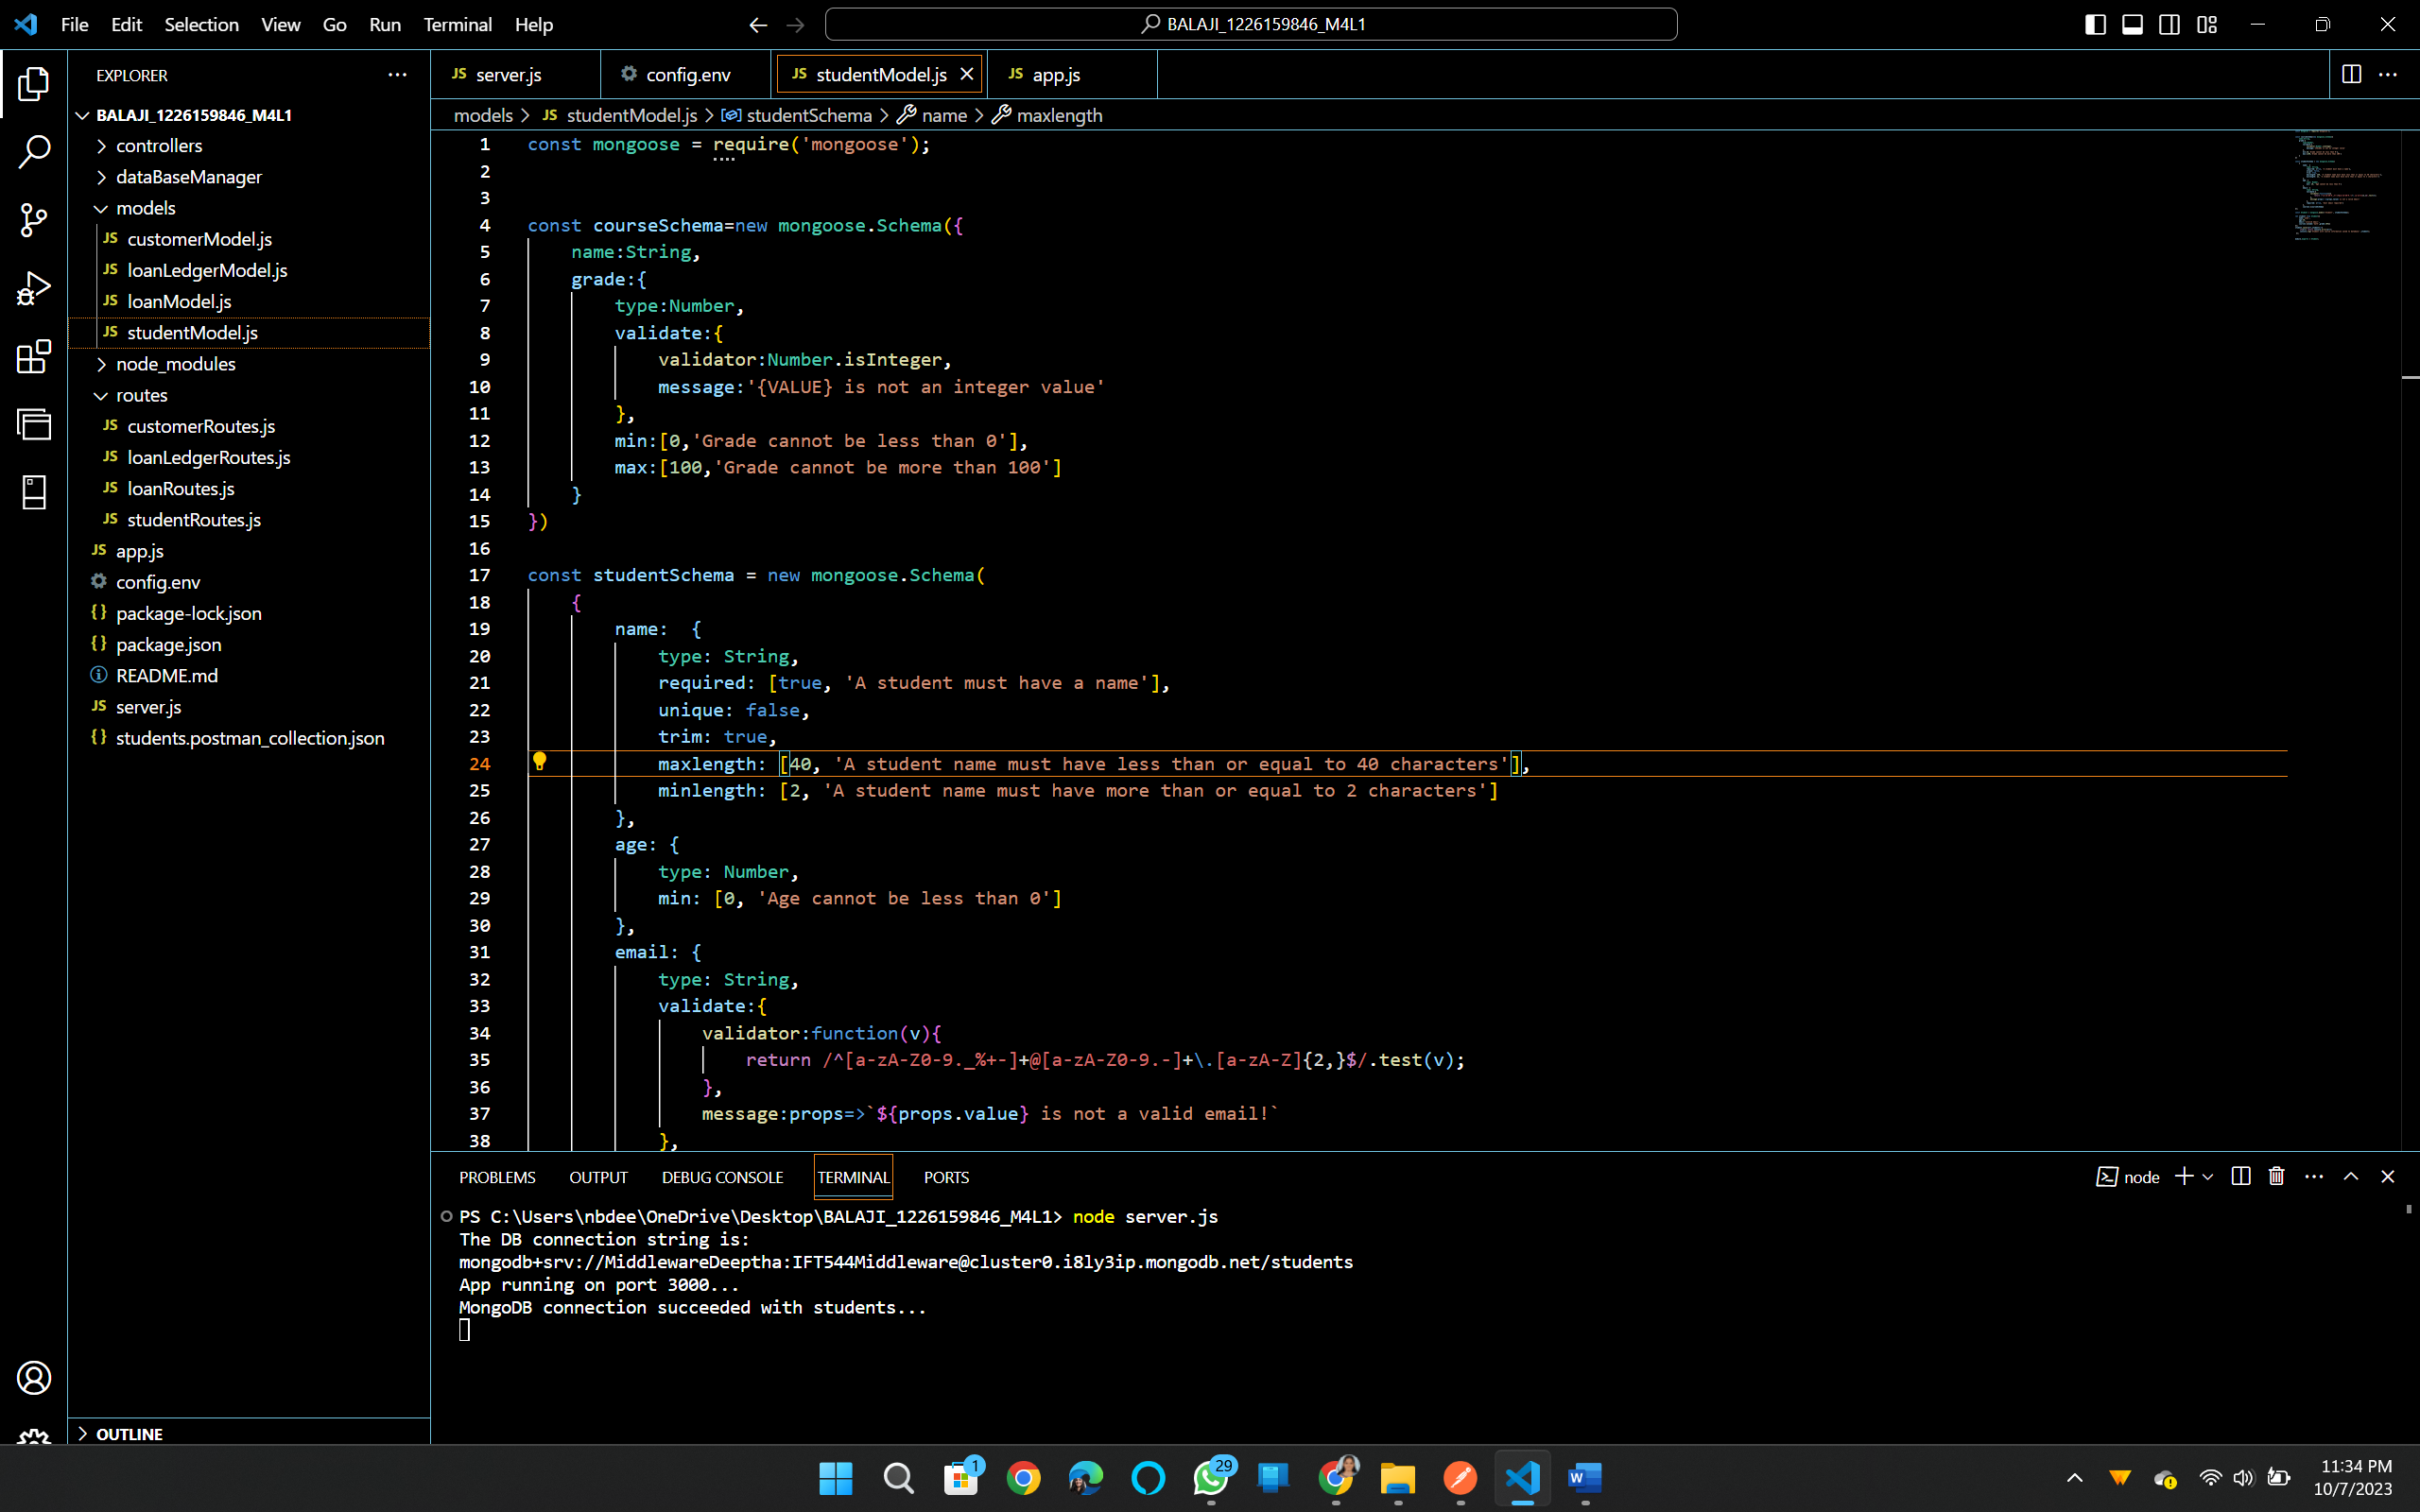

**Course info is added**

**Task 4: Validating Models in Mongoose**



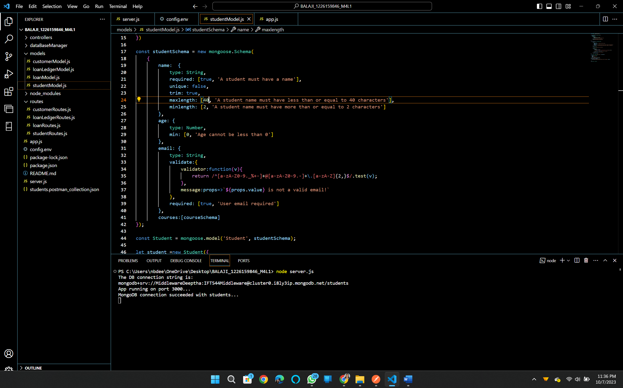

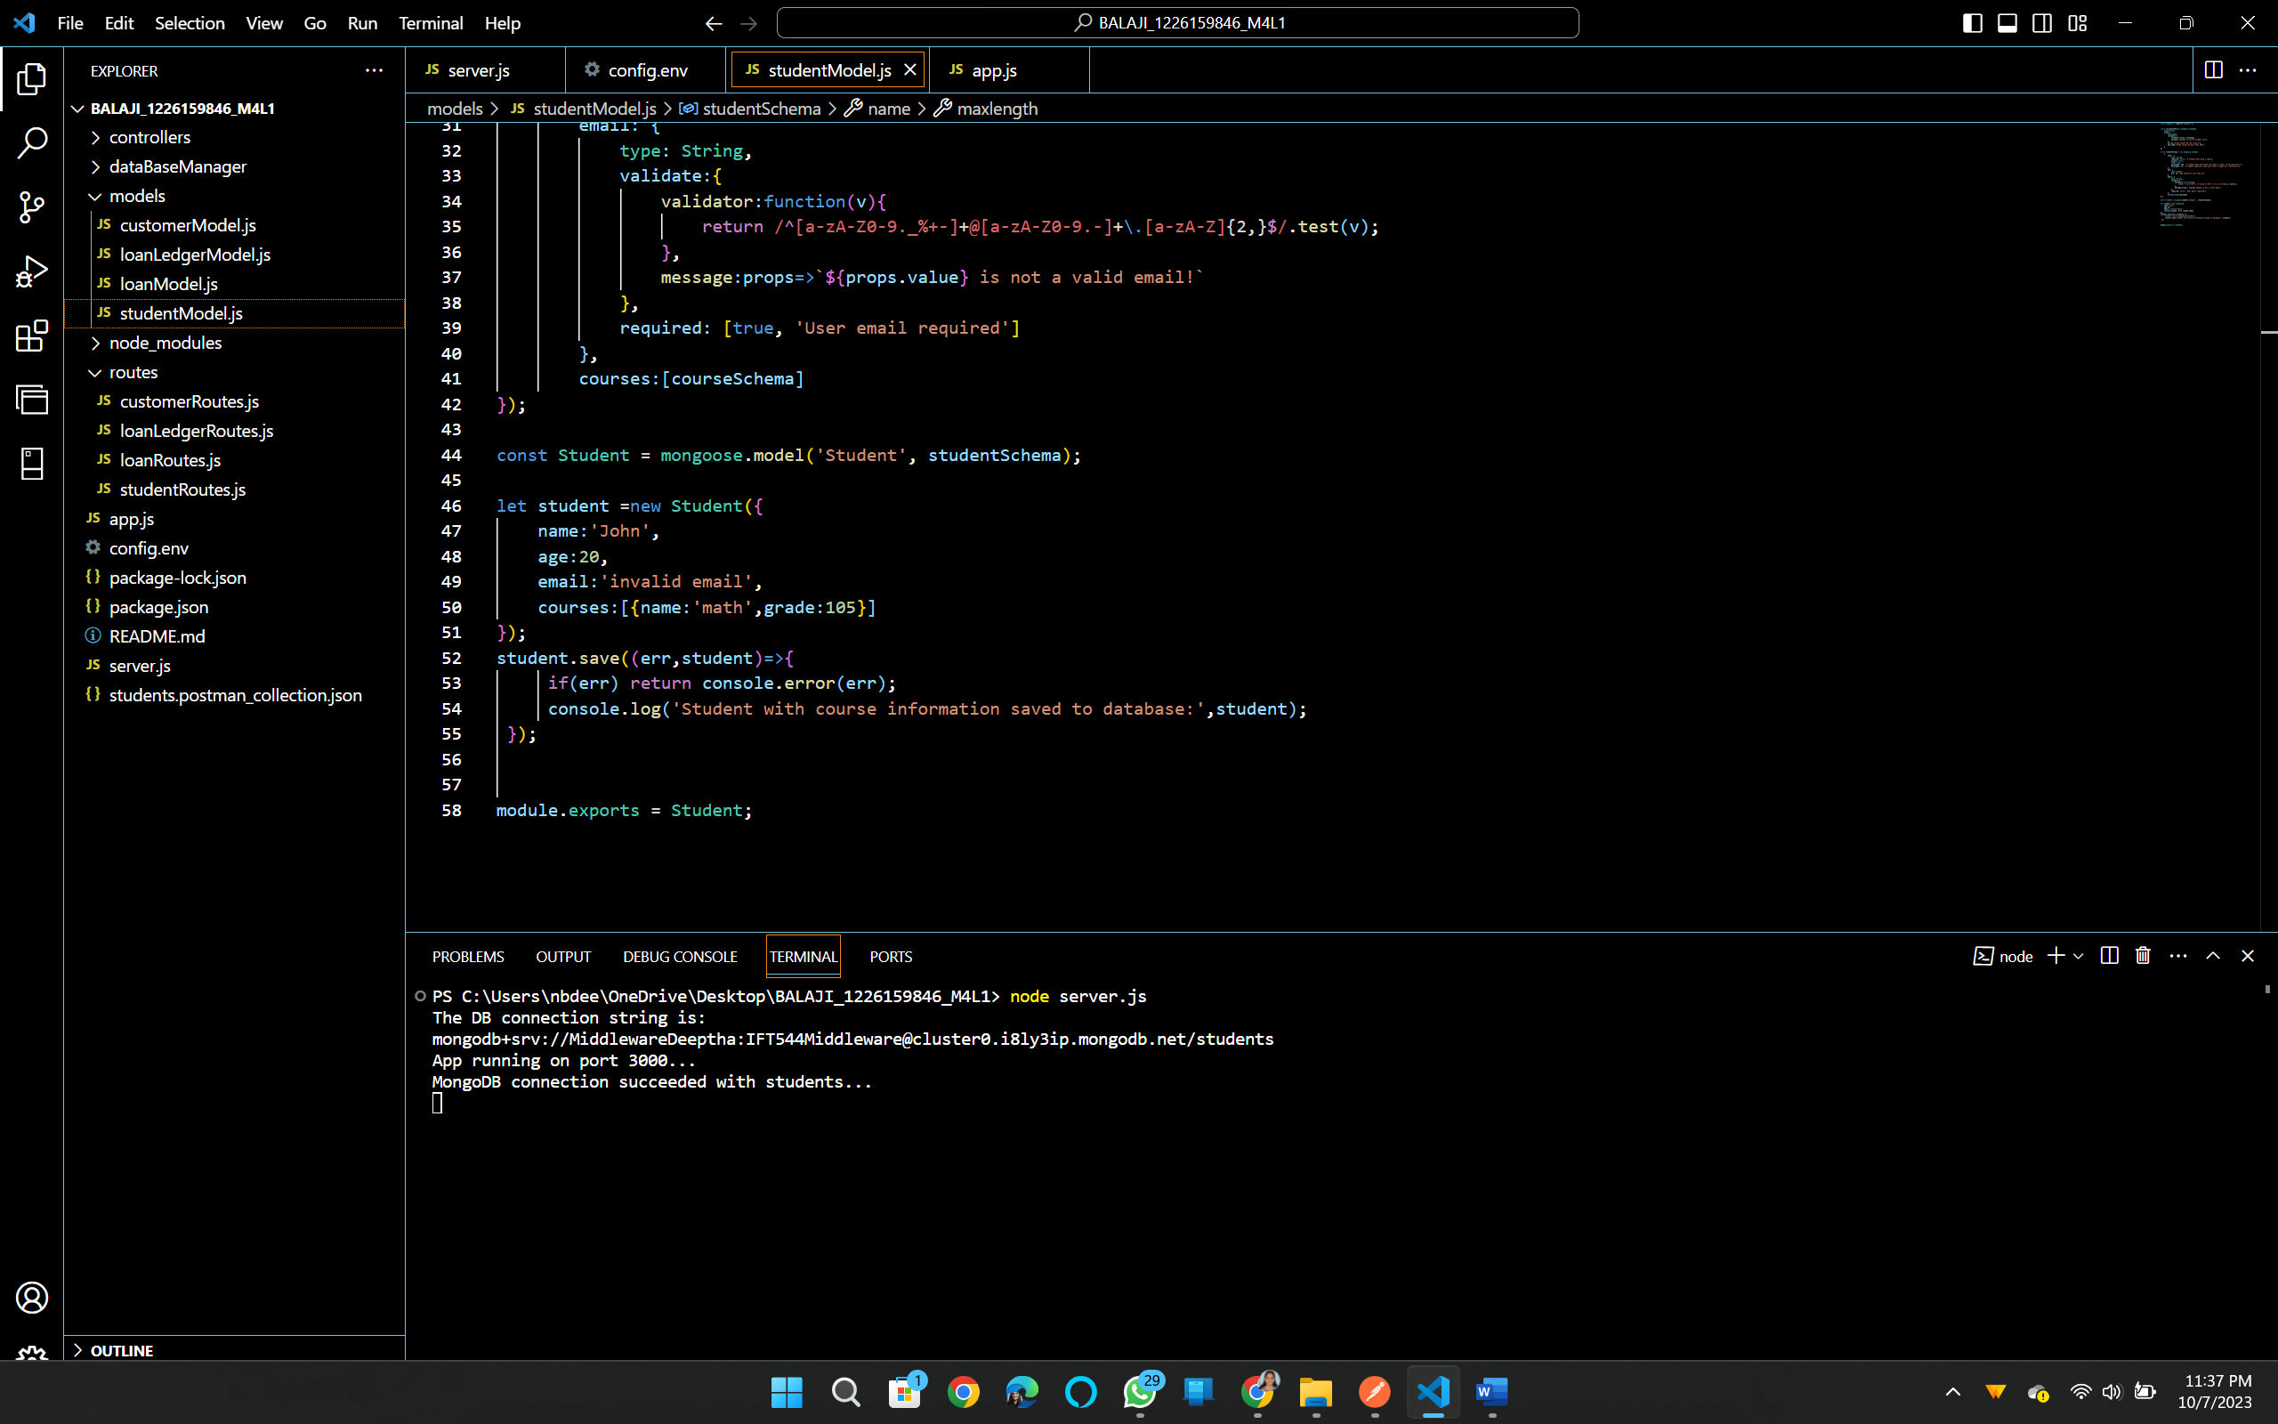

**Task 5: Connecting to MongoDB Database with Mongoose:**

**server.js**

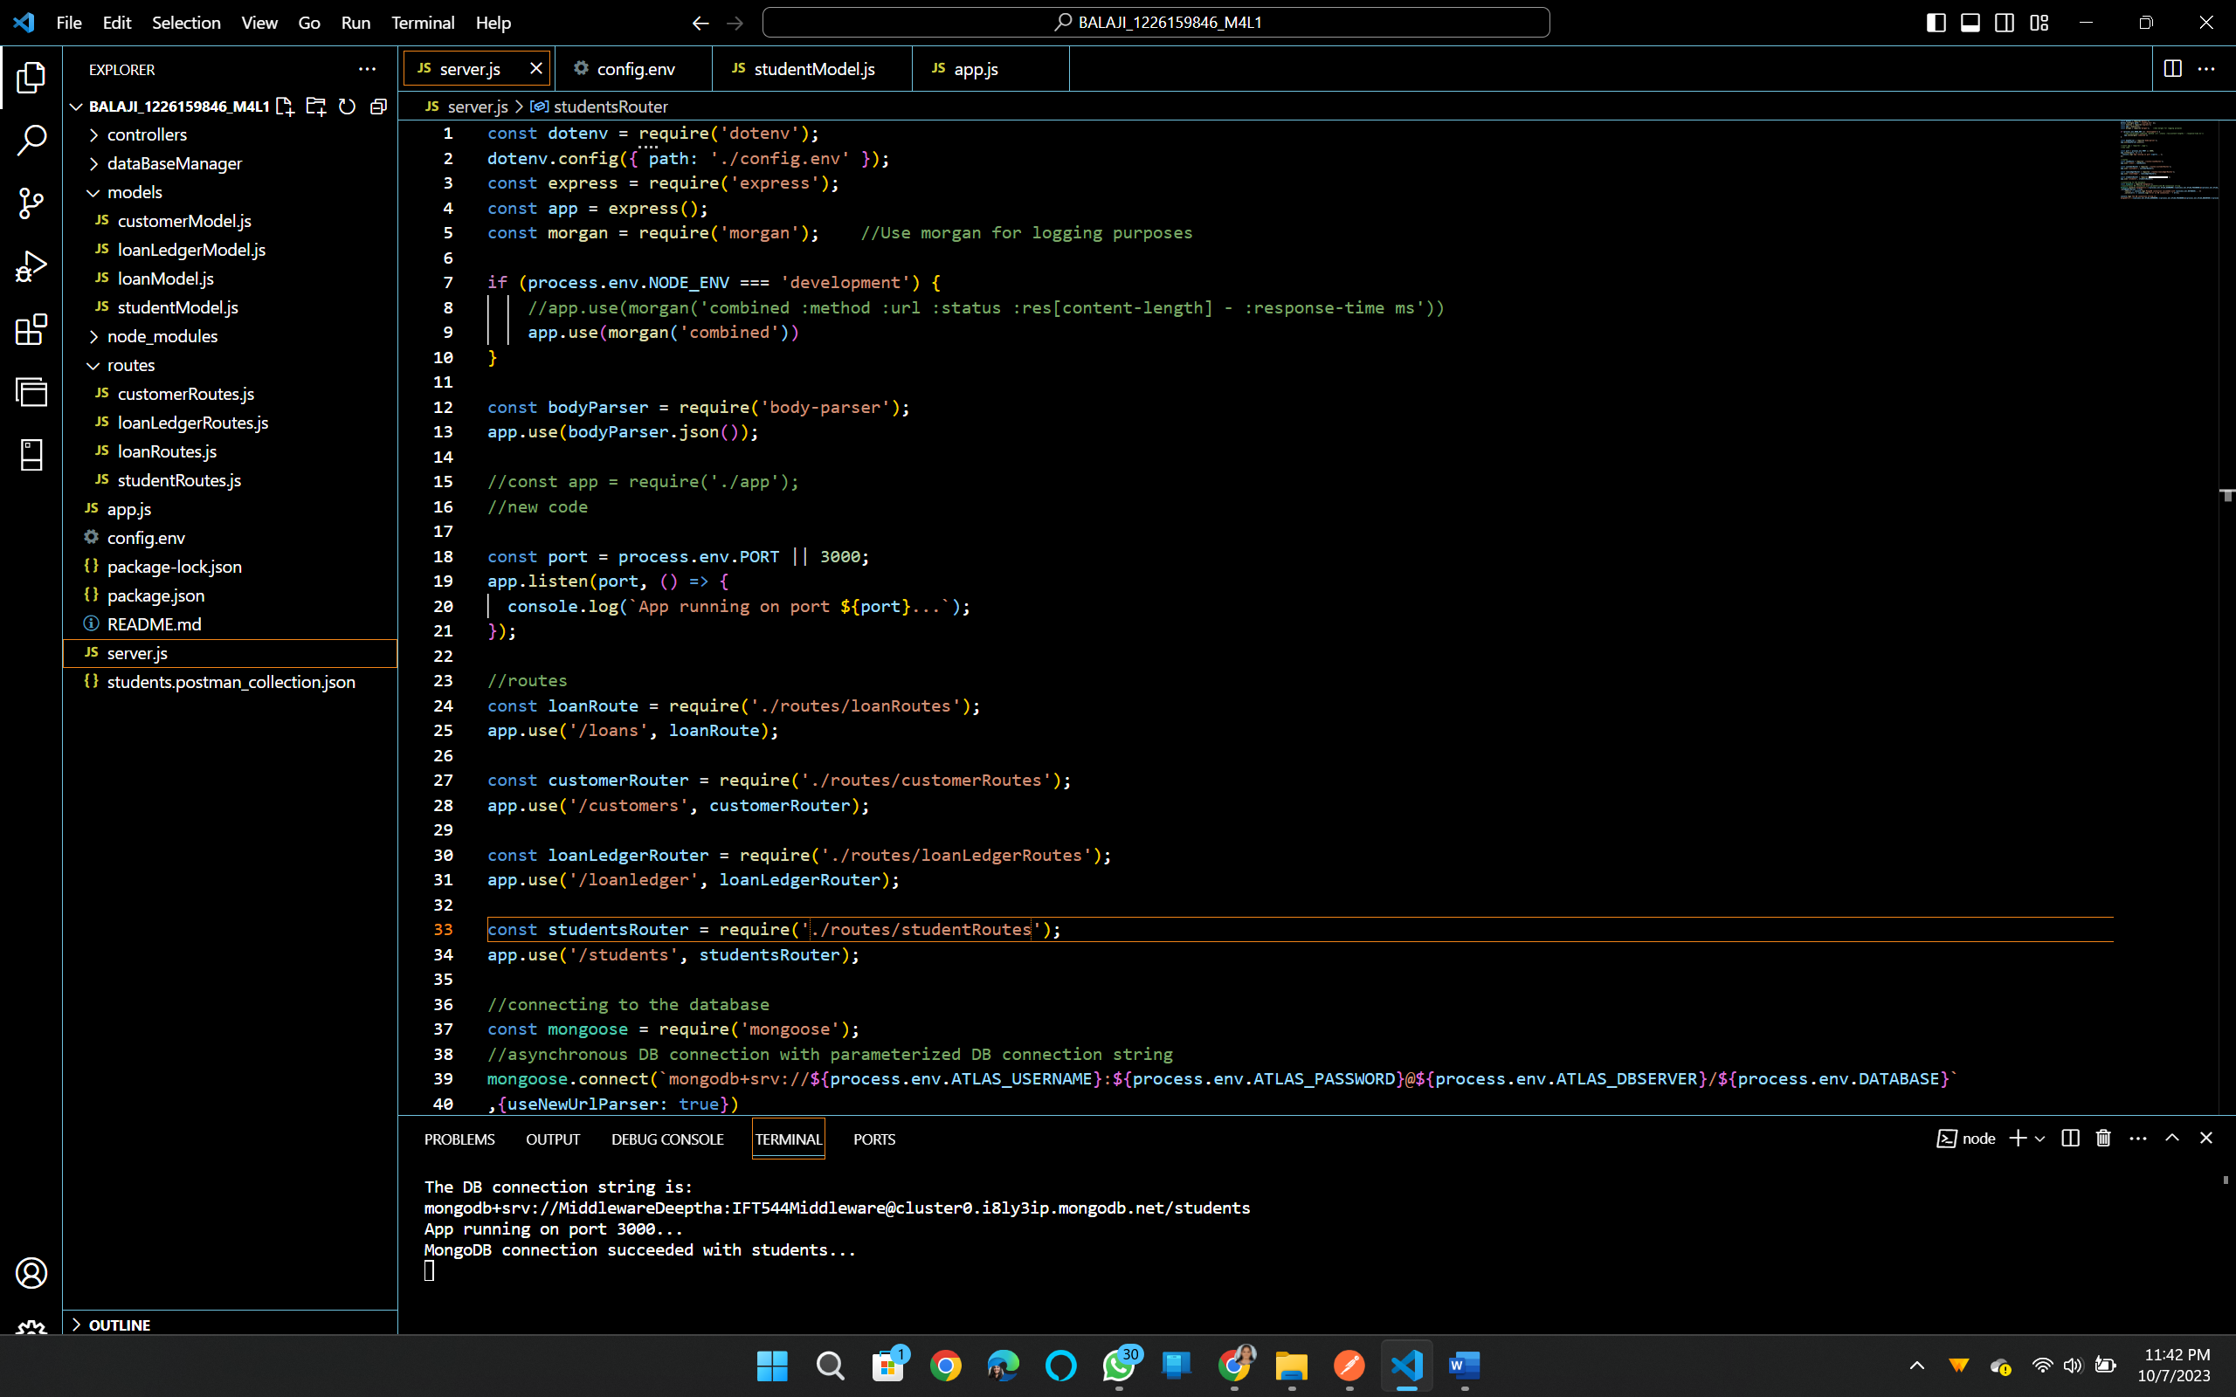

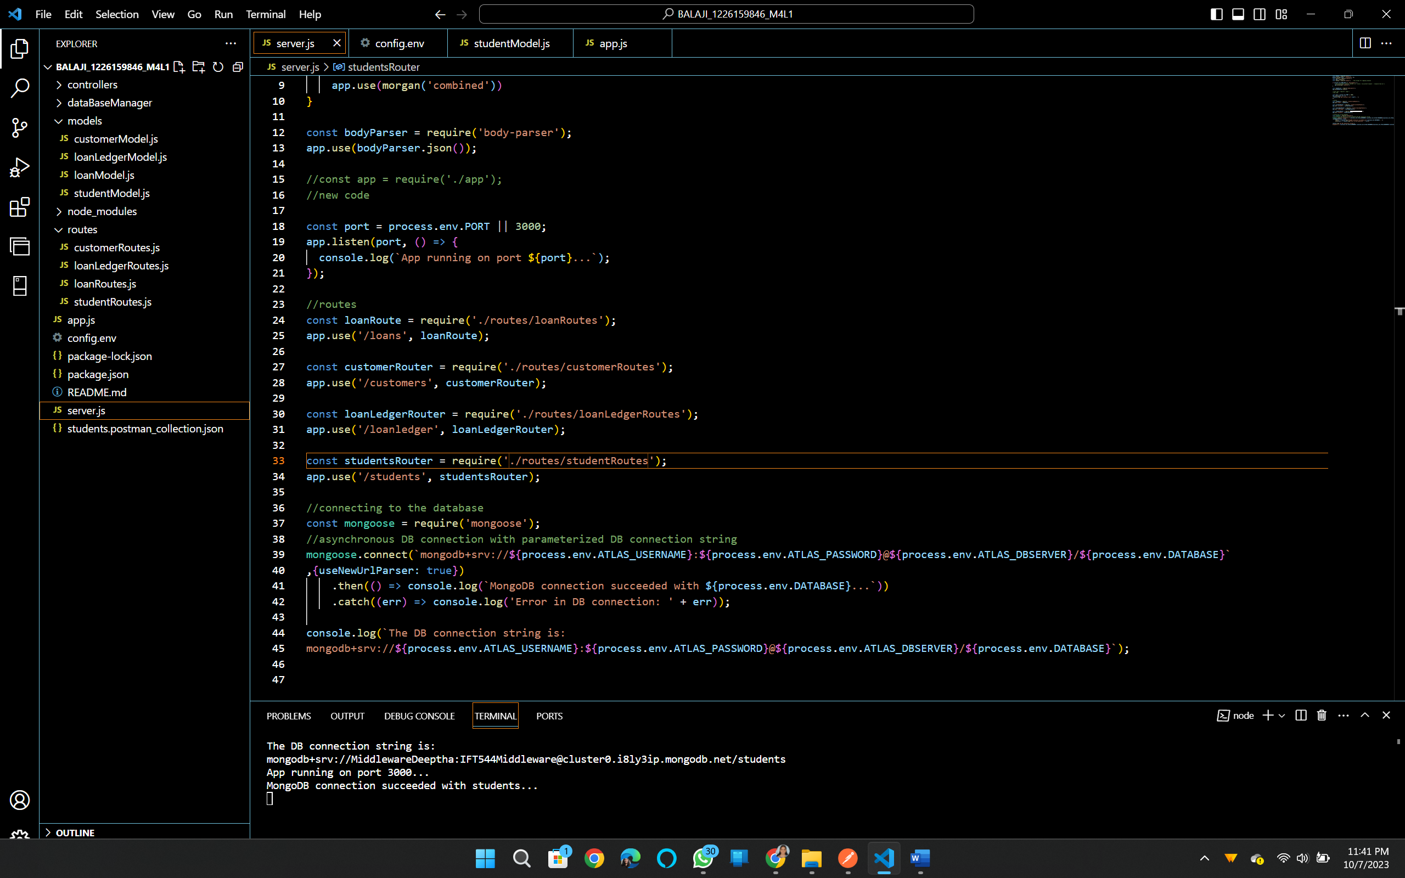

Connection established successfully.

**Task 6: Creating Models in Mongoose**

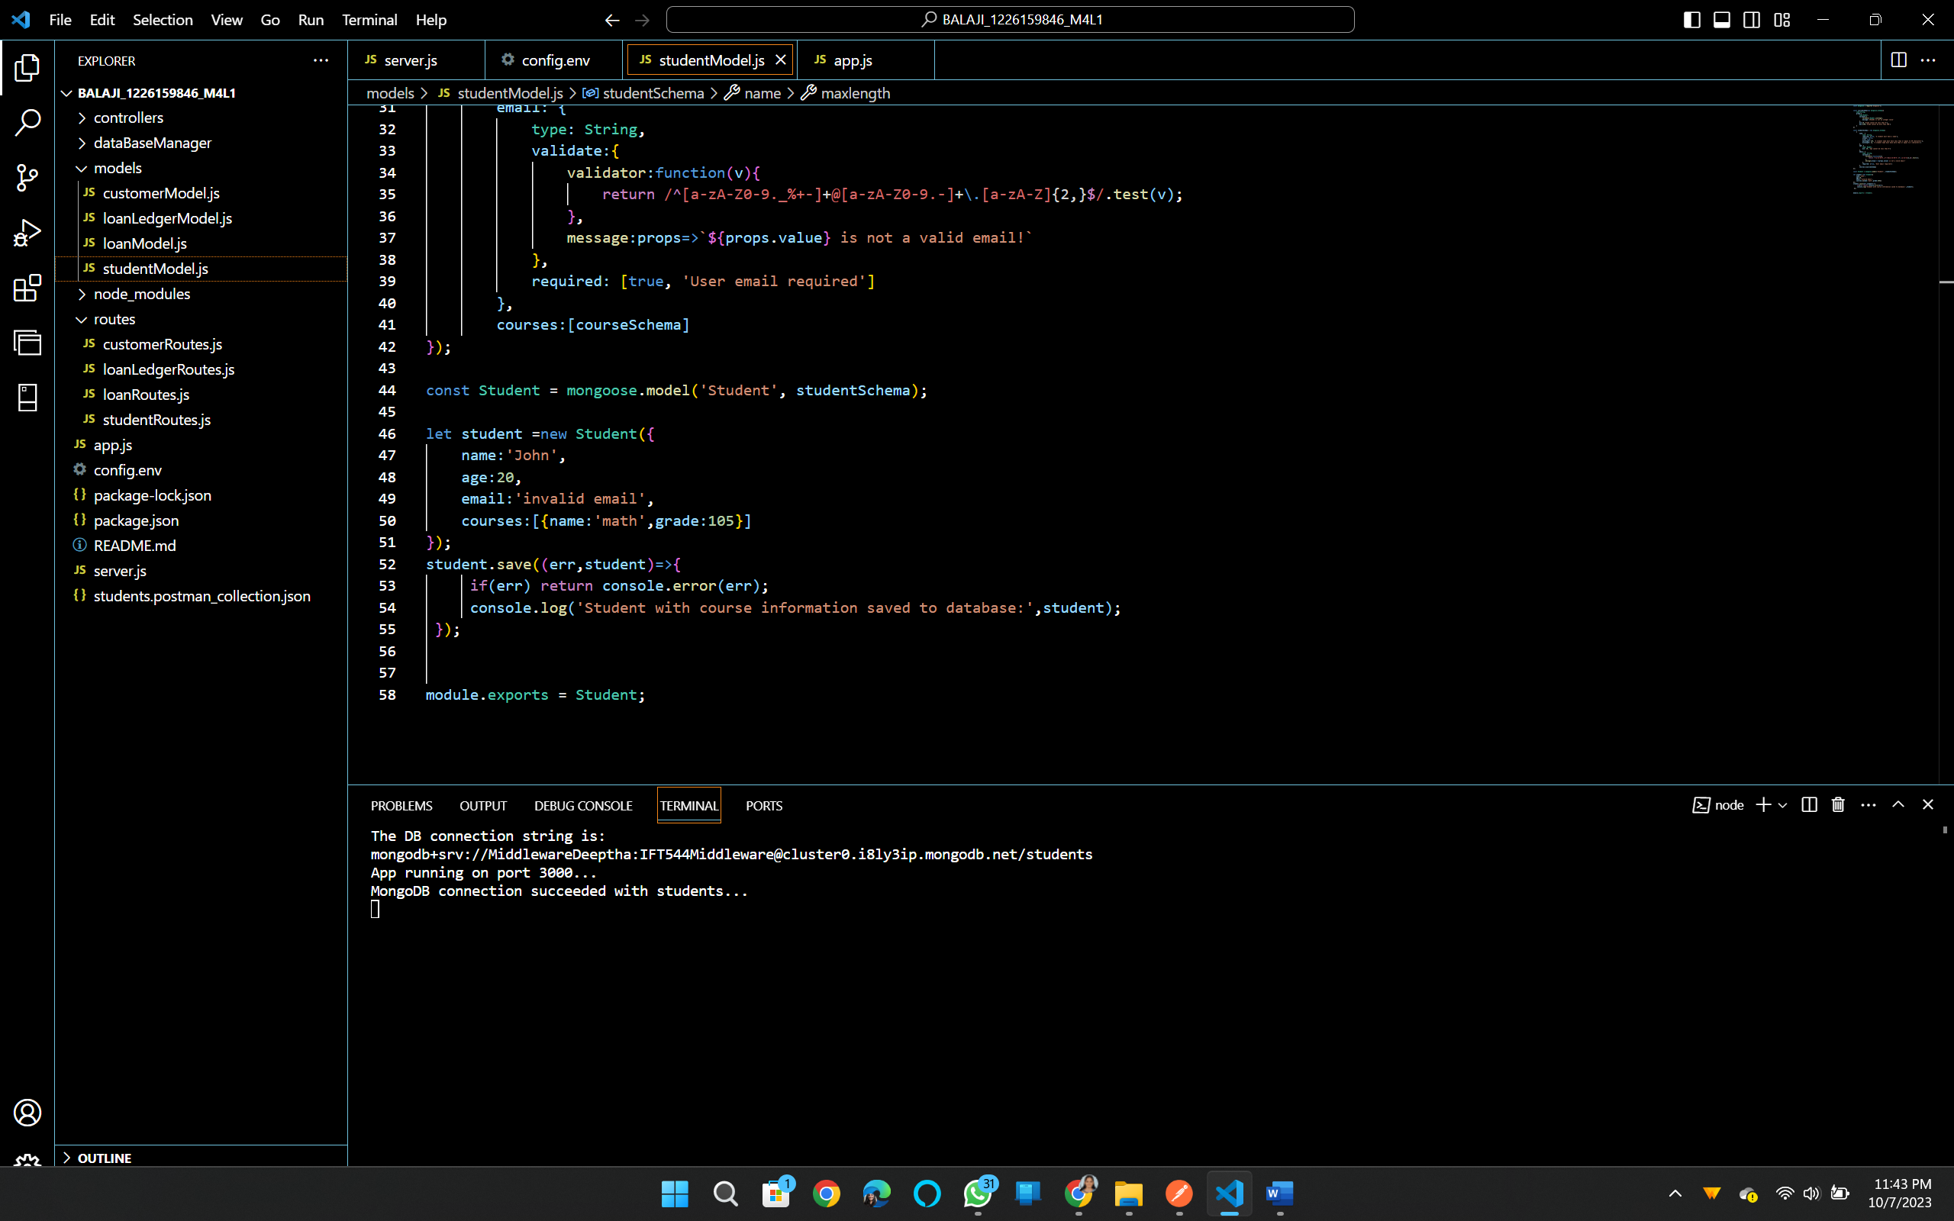

**Task 7 Validating Models in Mongoose:**

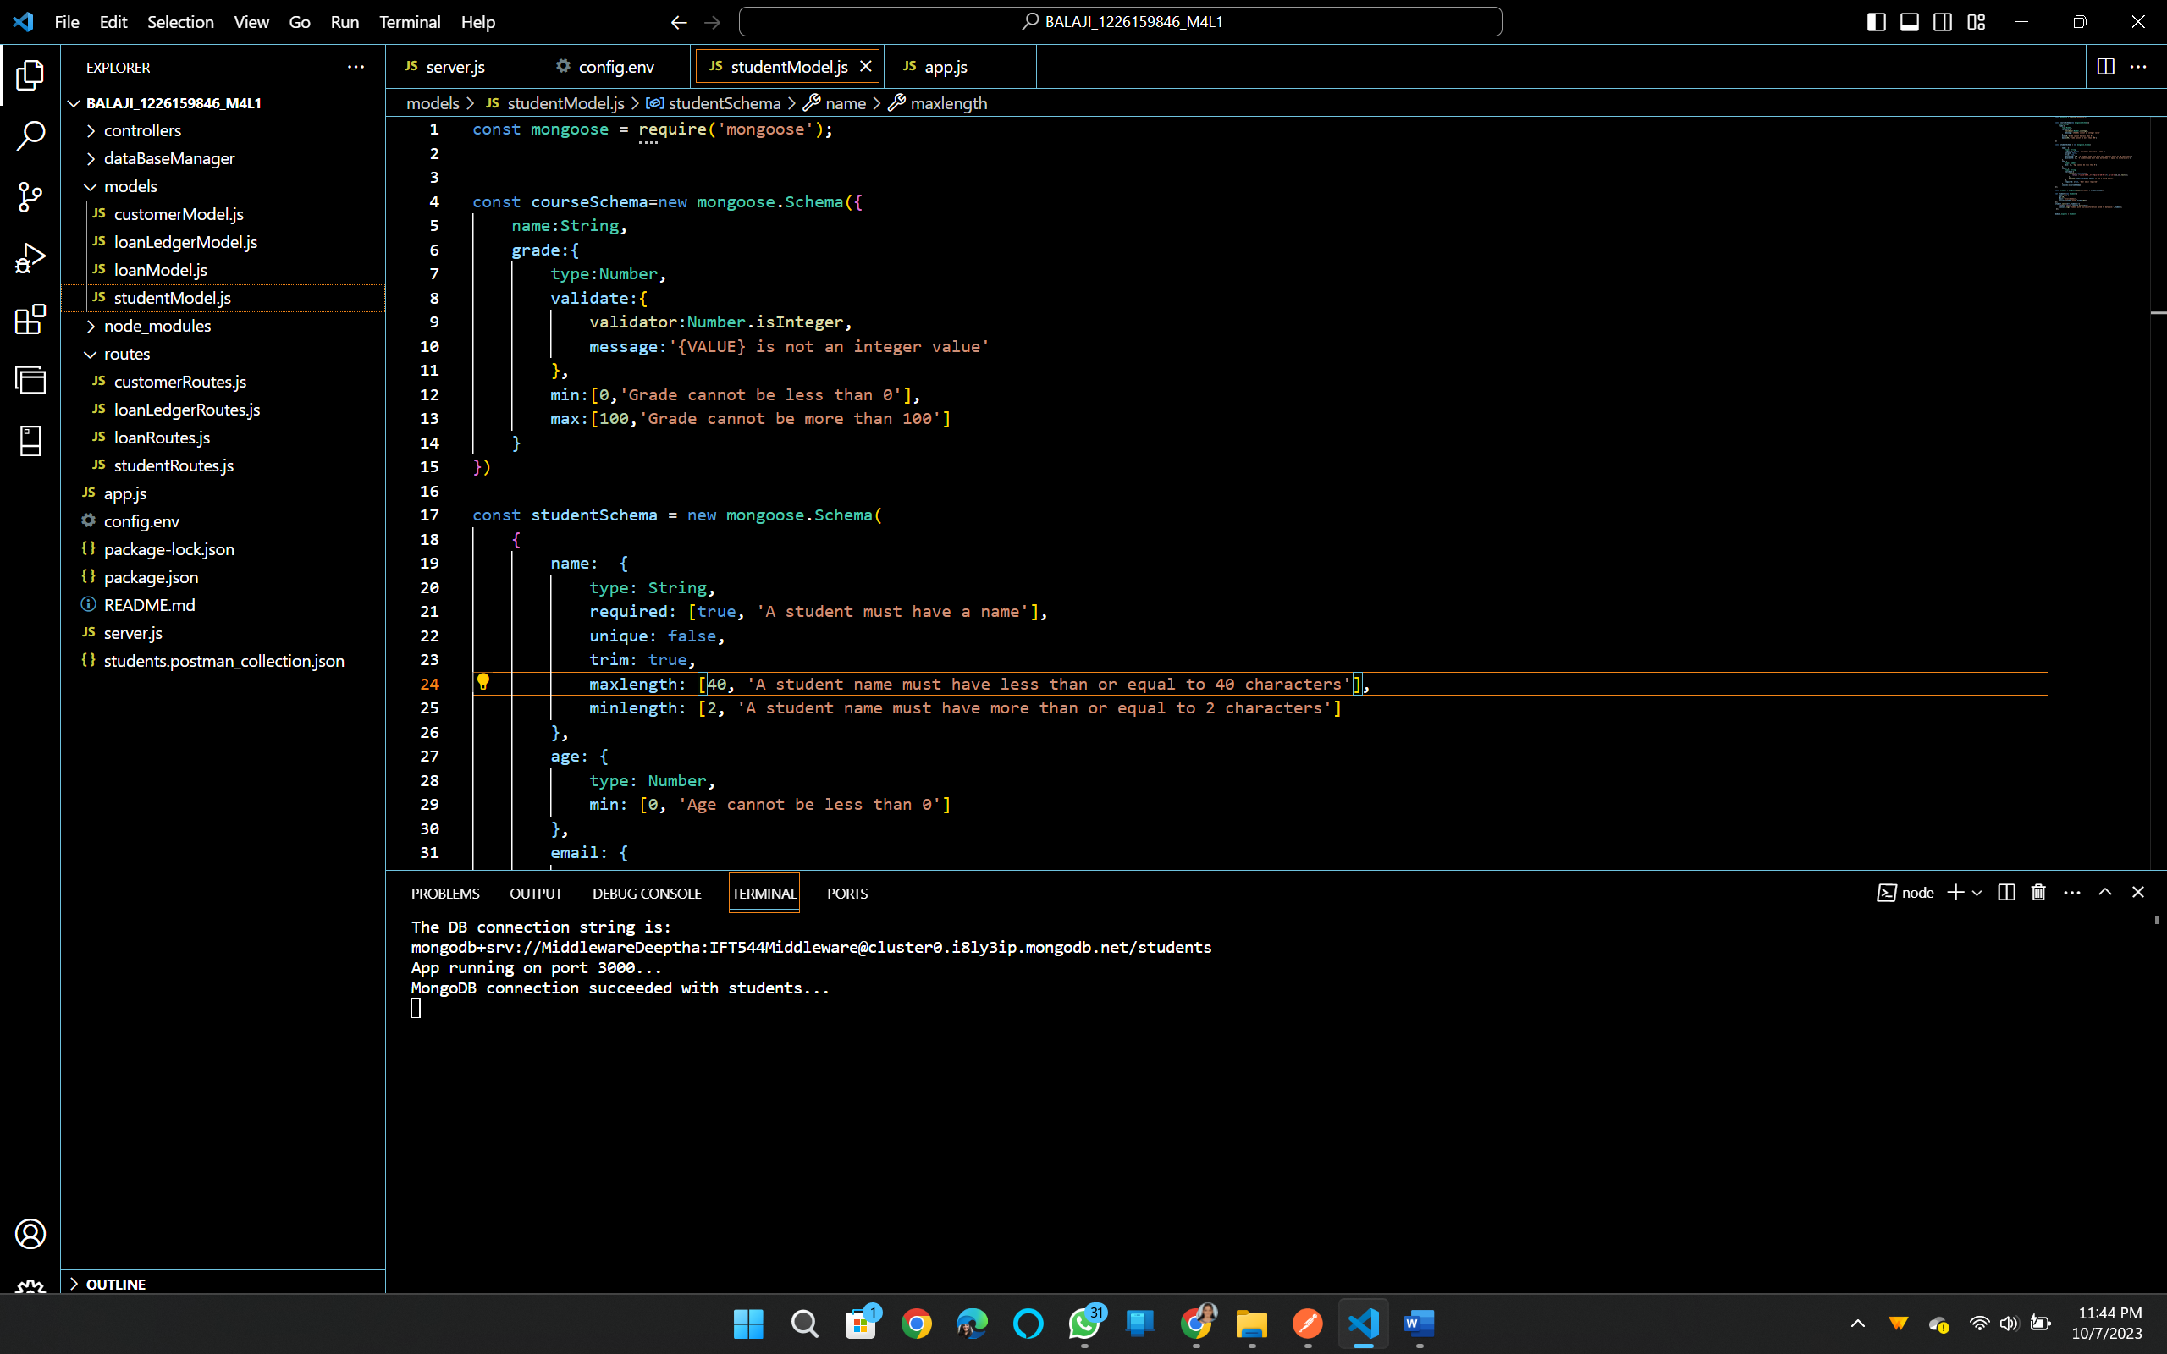

**Task 8:**

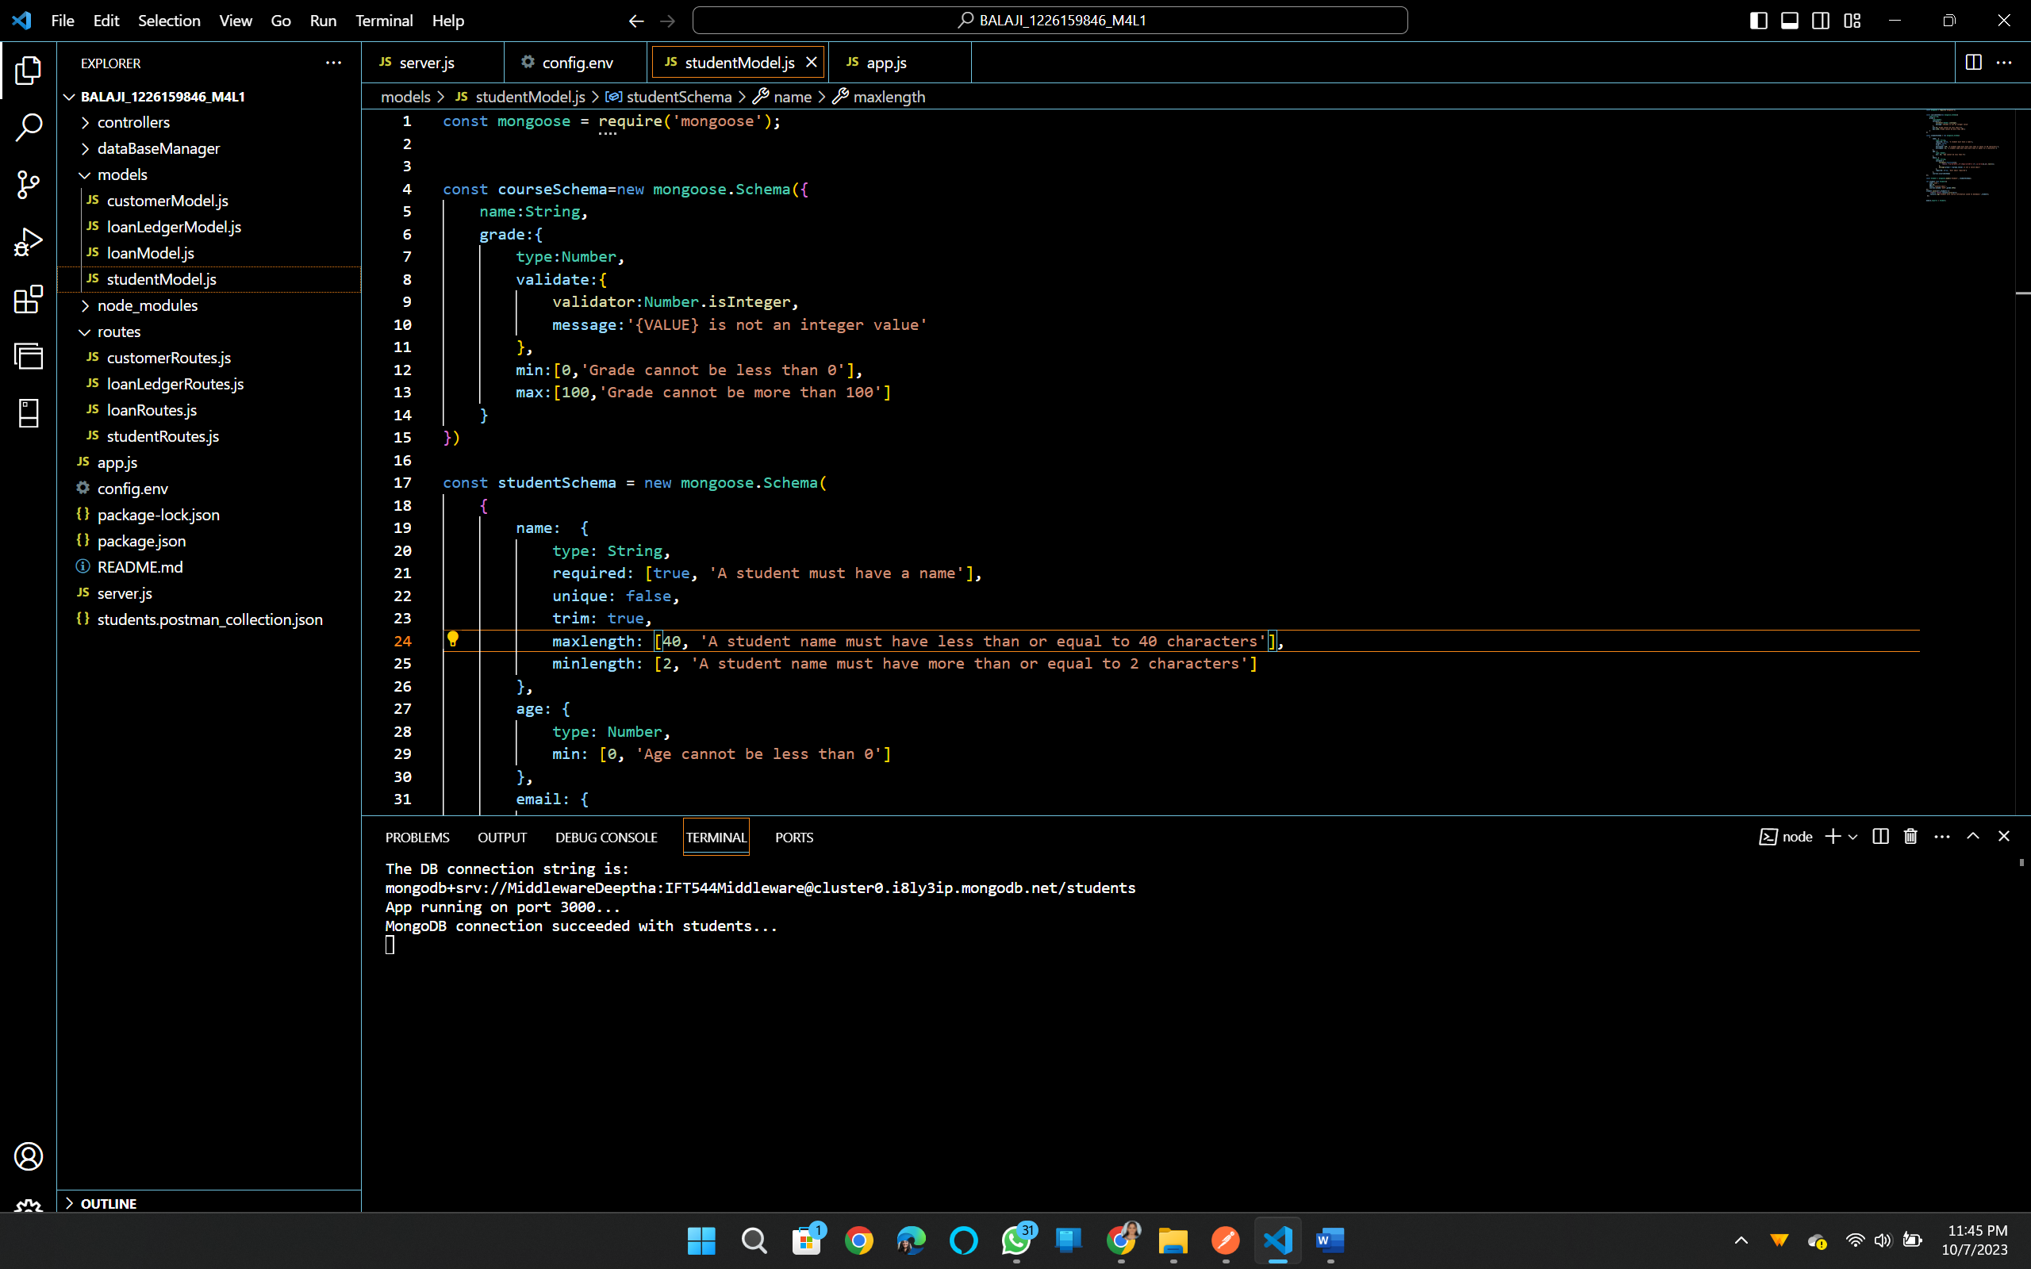

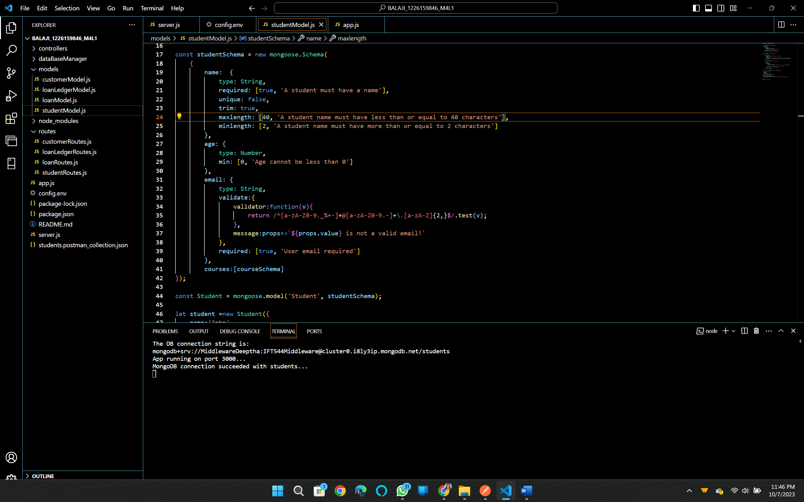

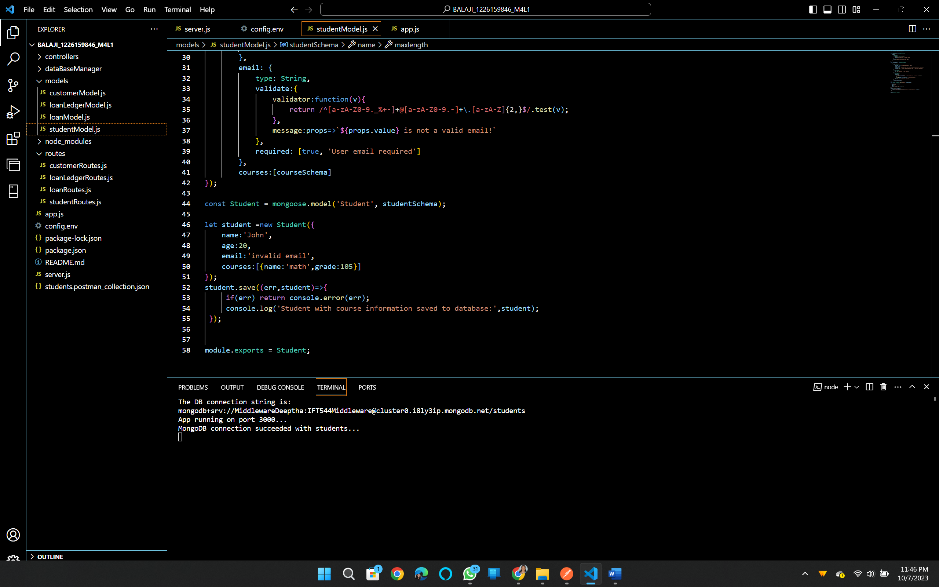

**Runing the application:**

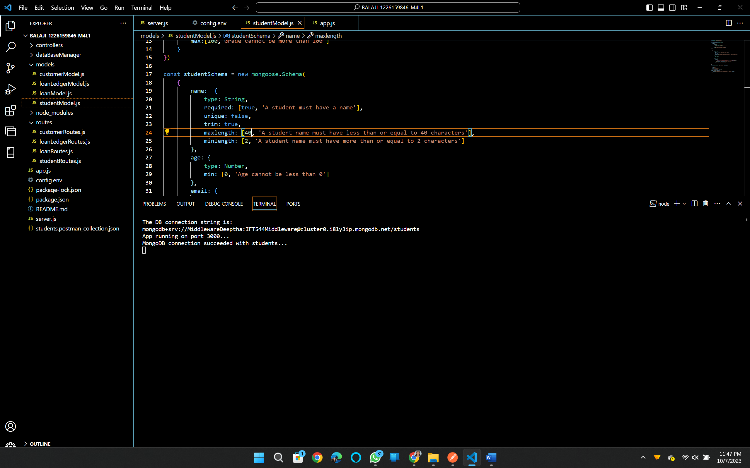

**Application ran successfully.**

**Testing:**

**Post:** 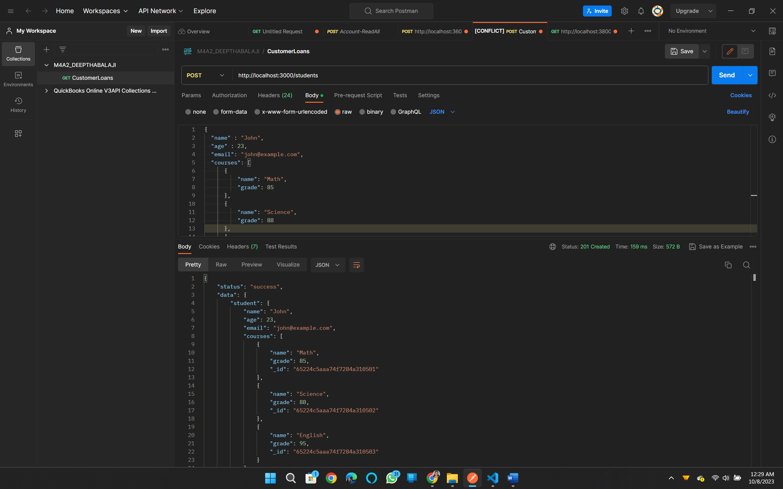

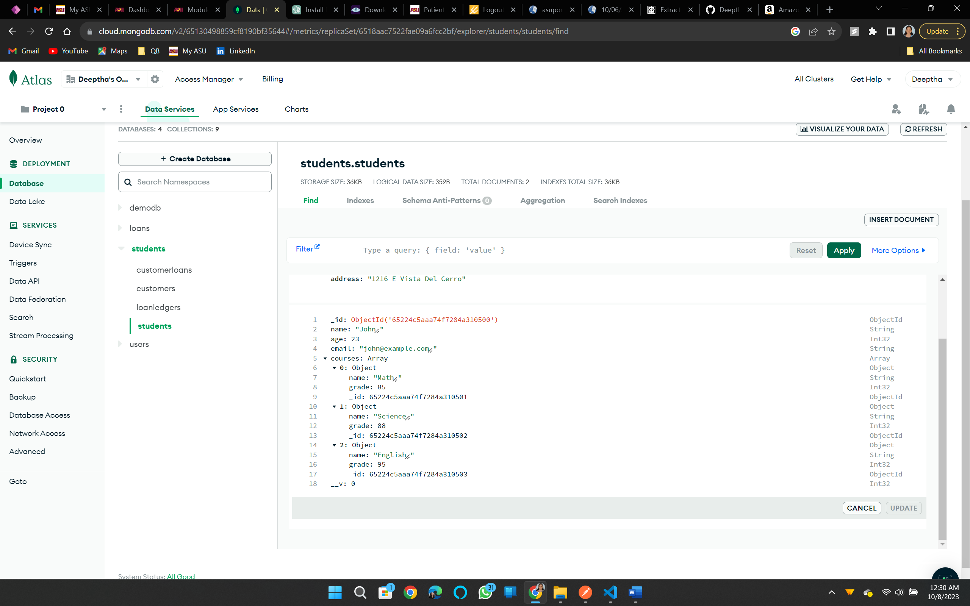

**GET:**

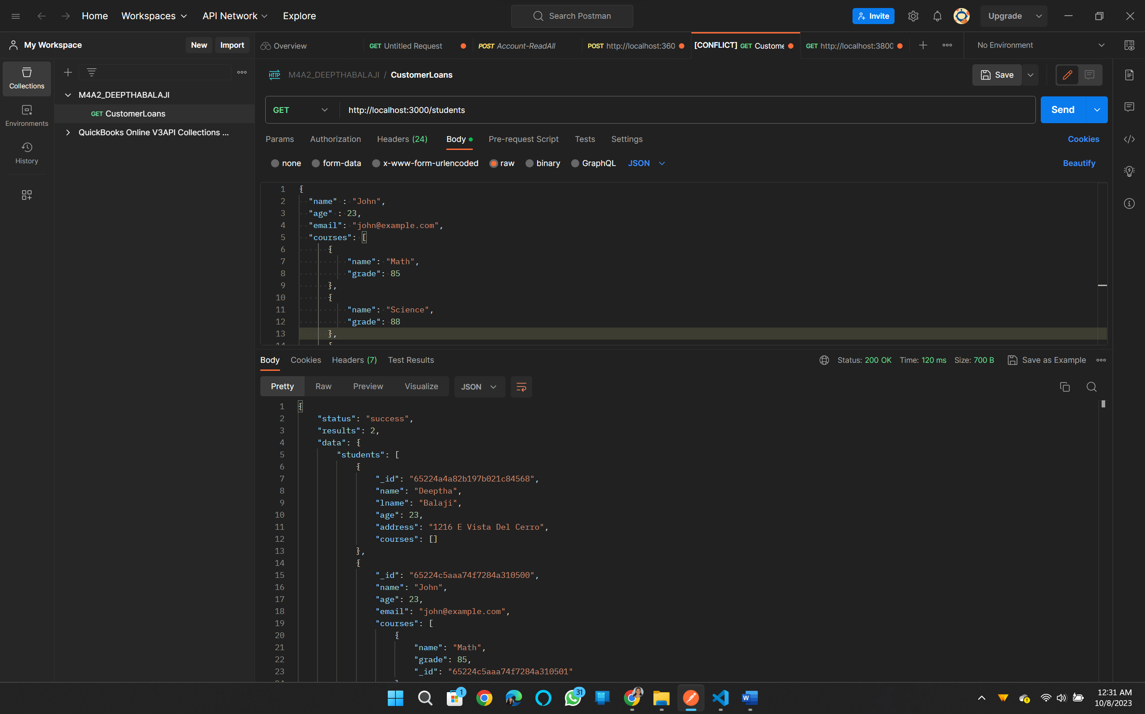

**GET by ID:**

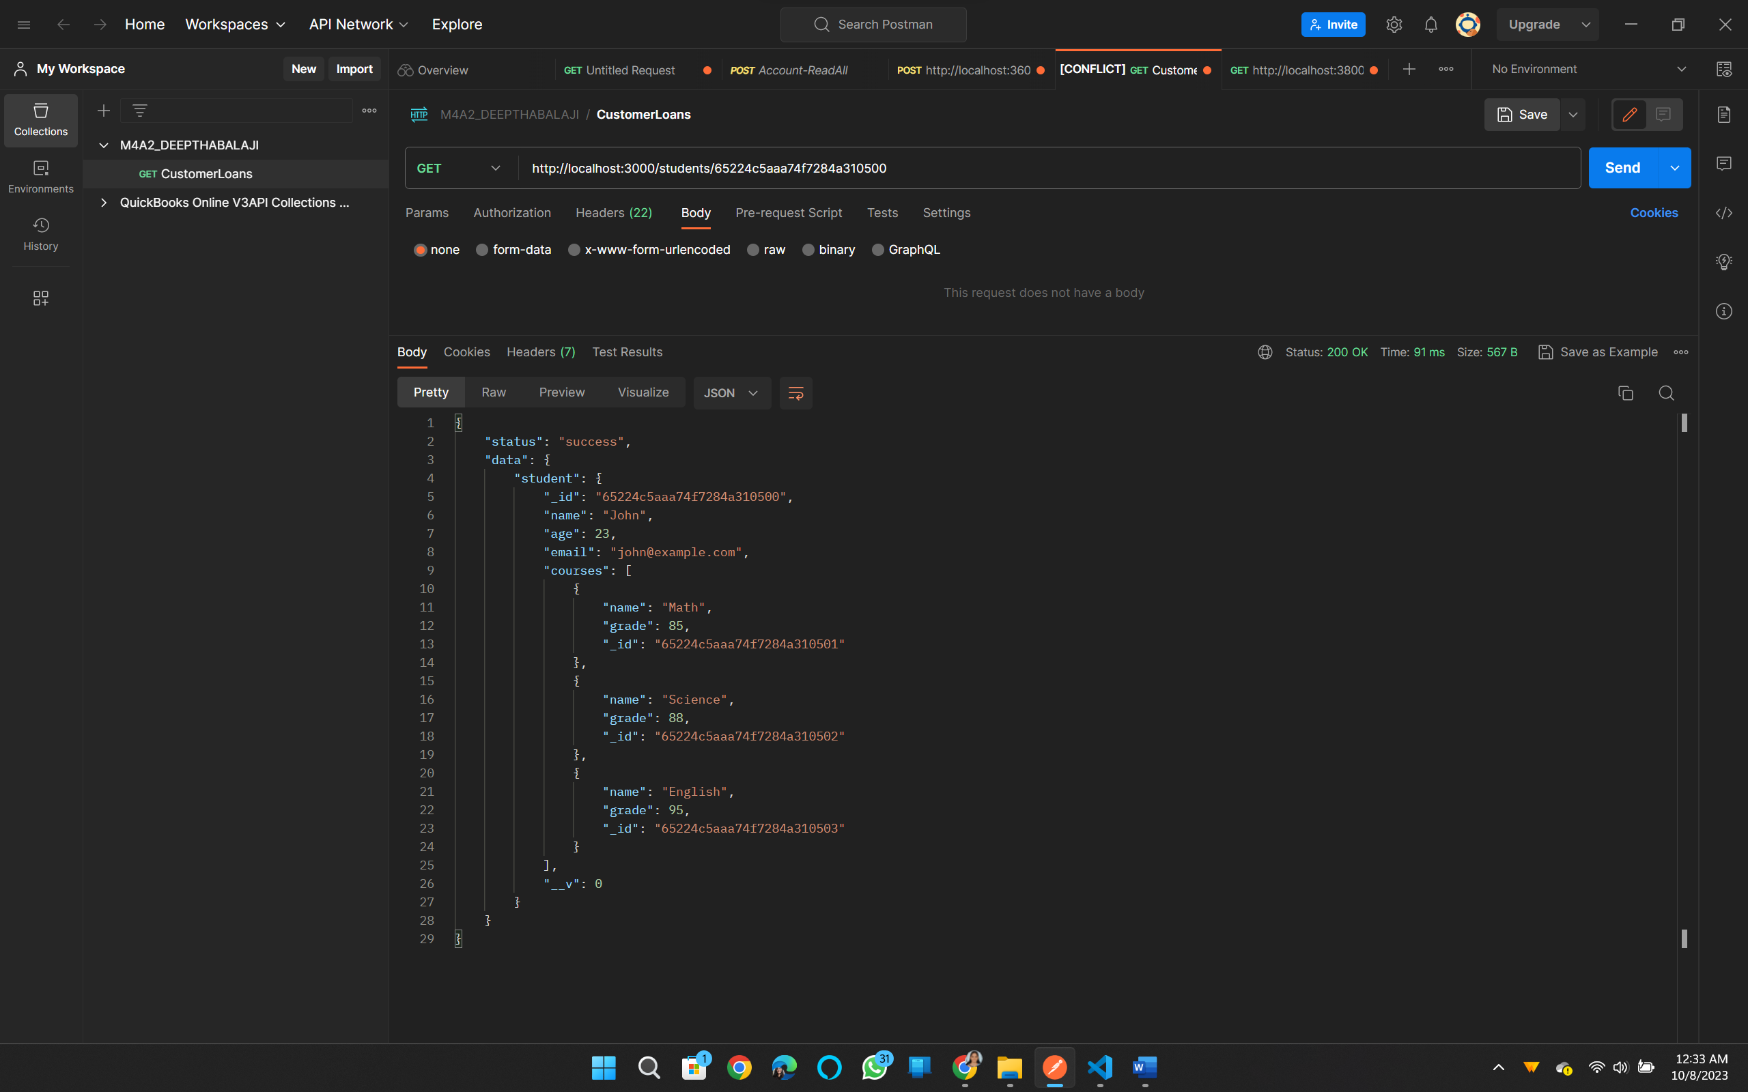

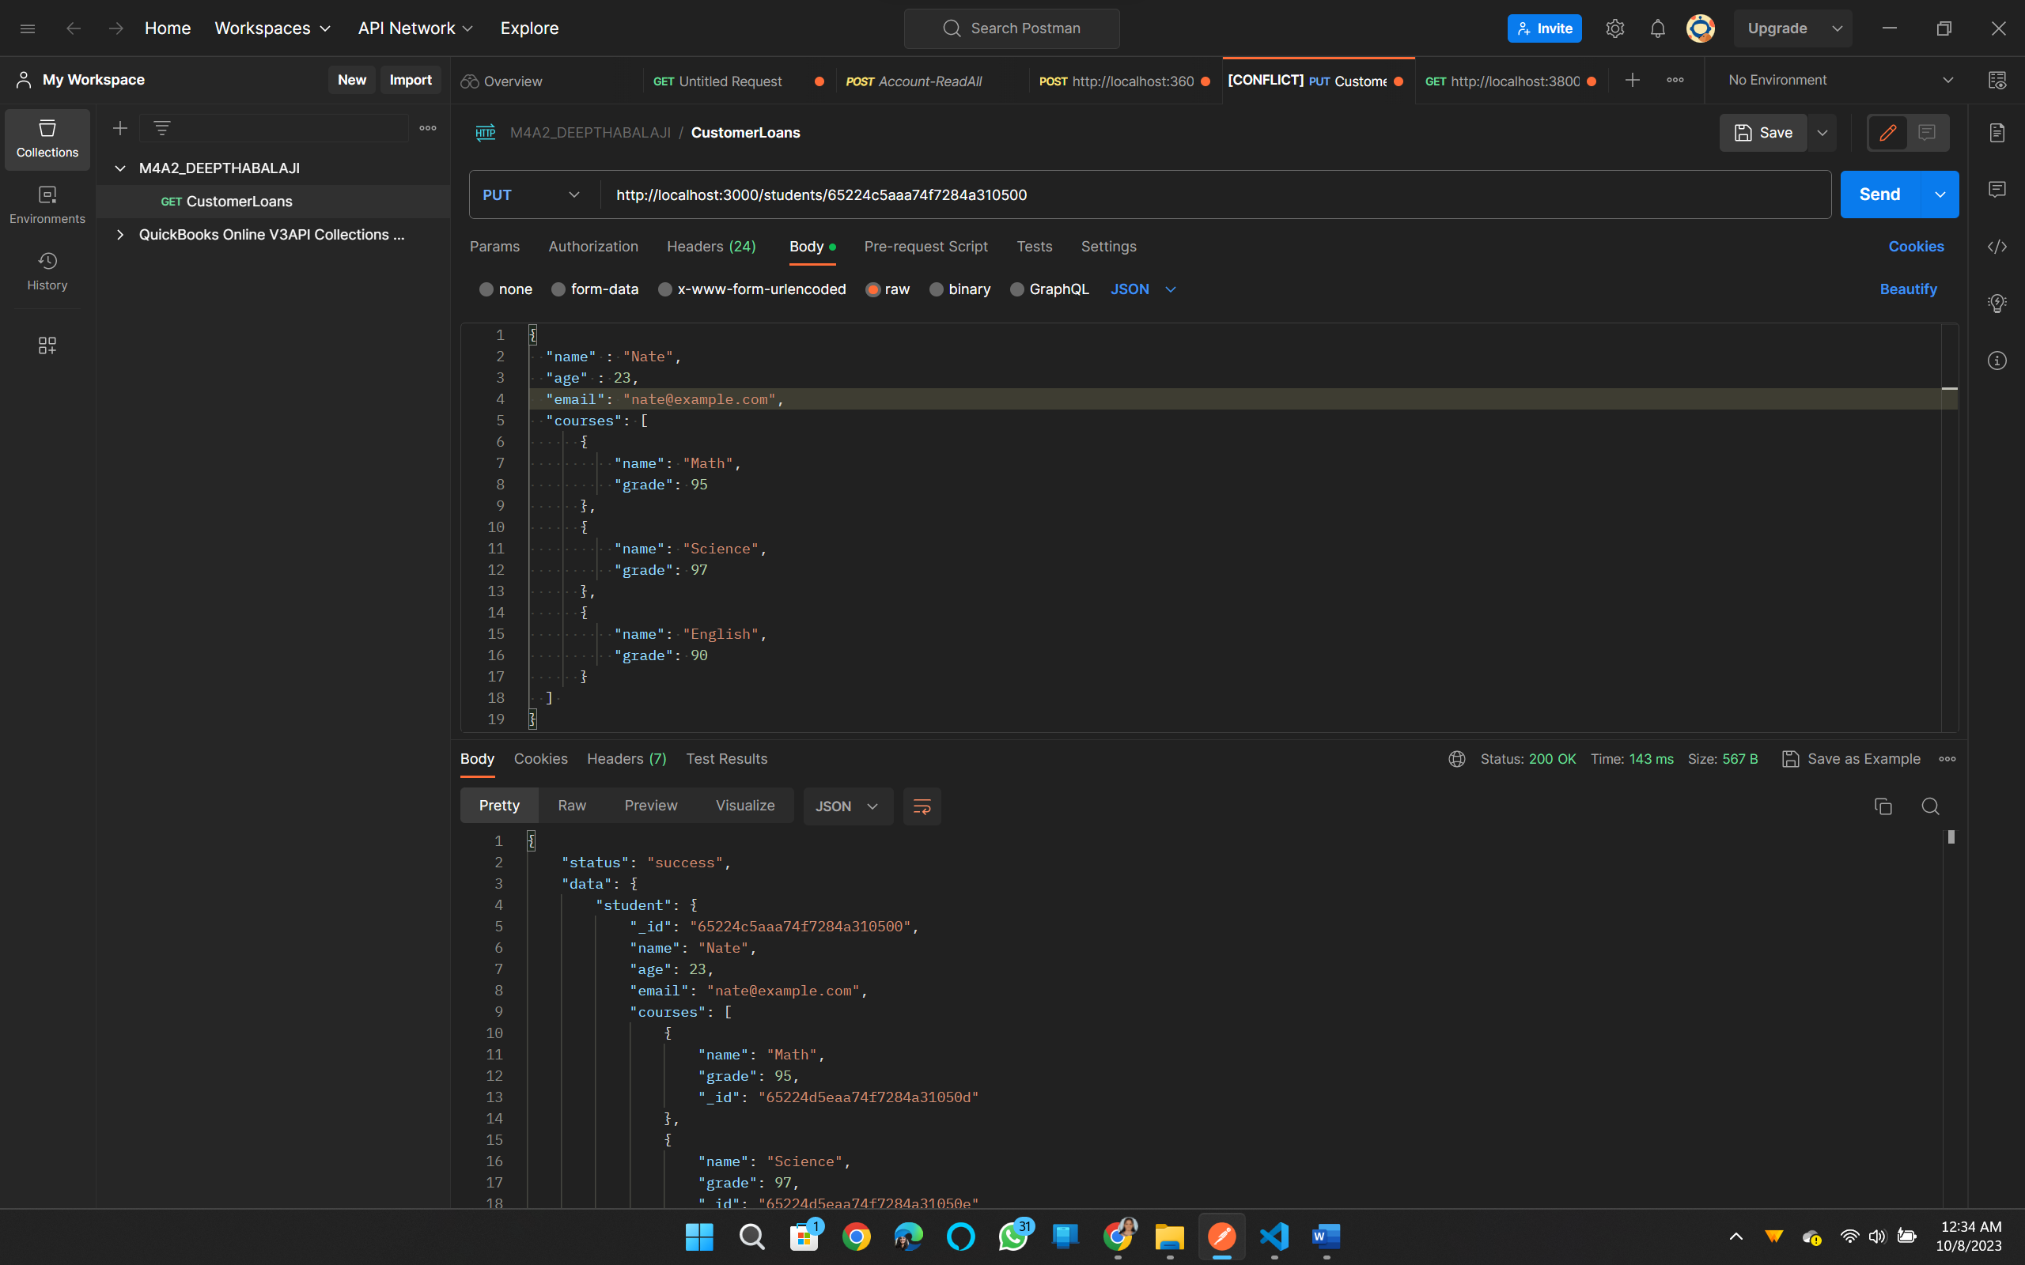

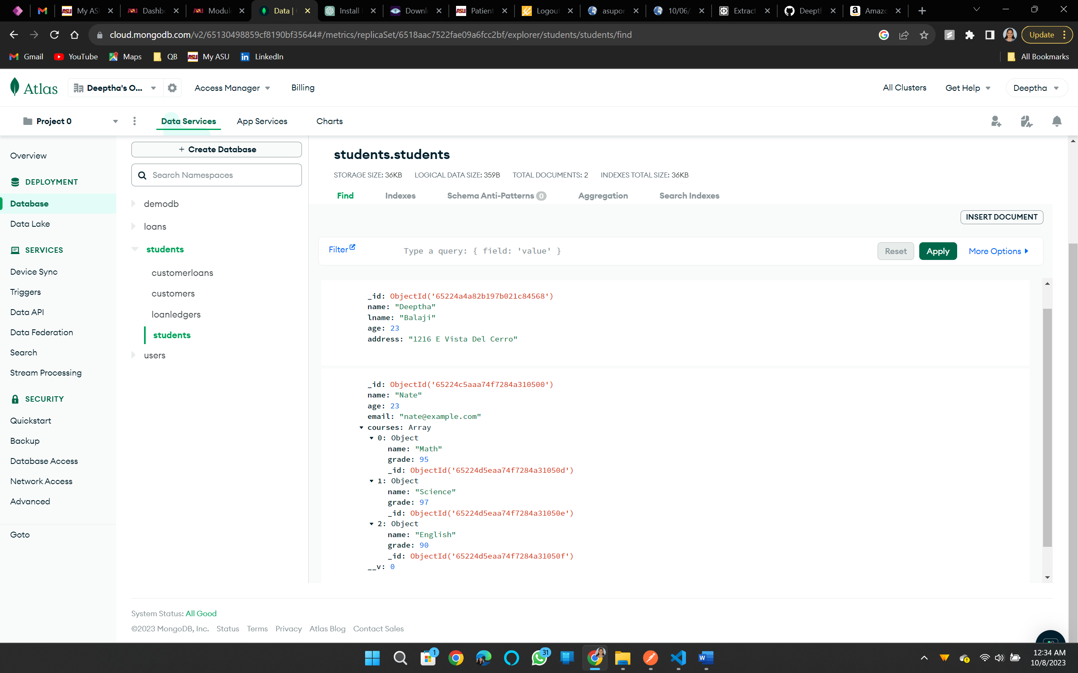

**Name, e-mail and the marks are updated.**

**Delete:**

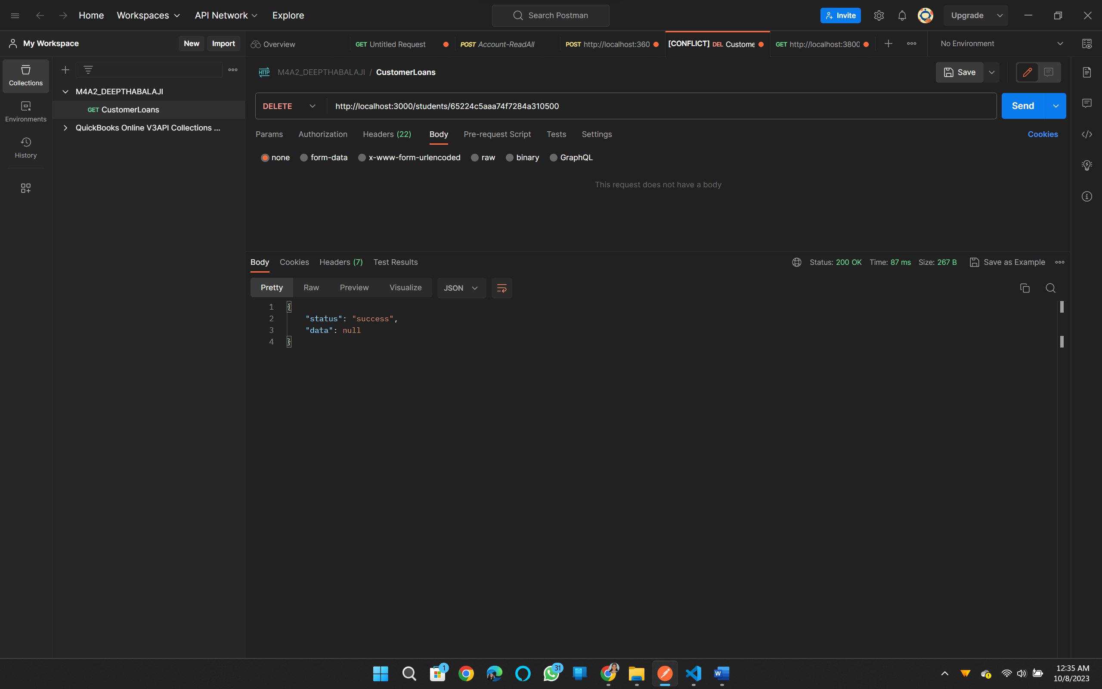

**After deleting:**

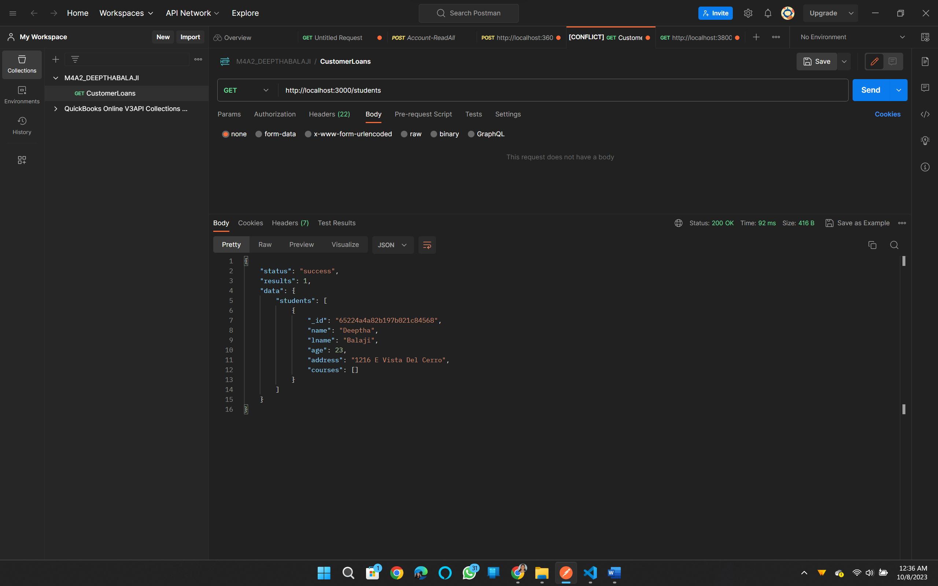

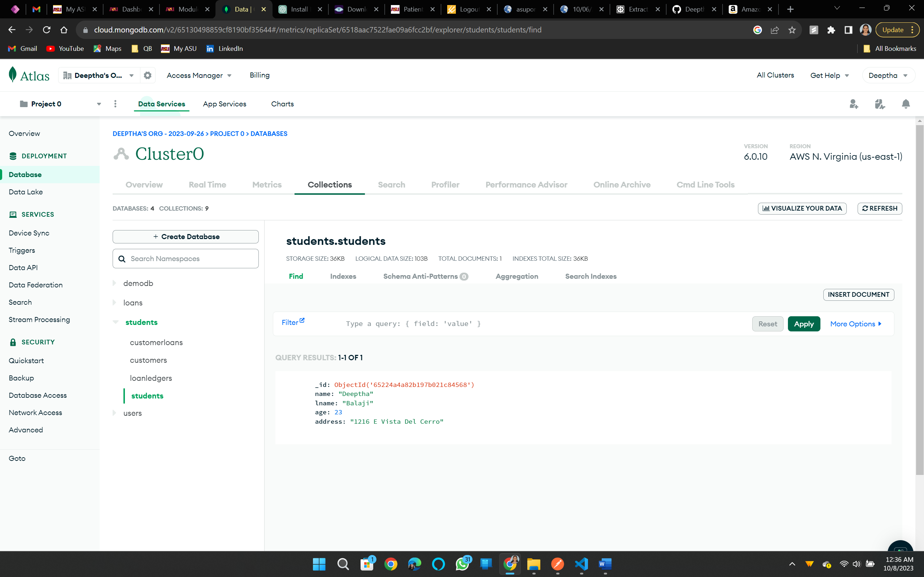

**Student controller:**

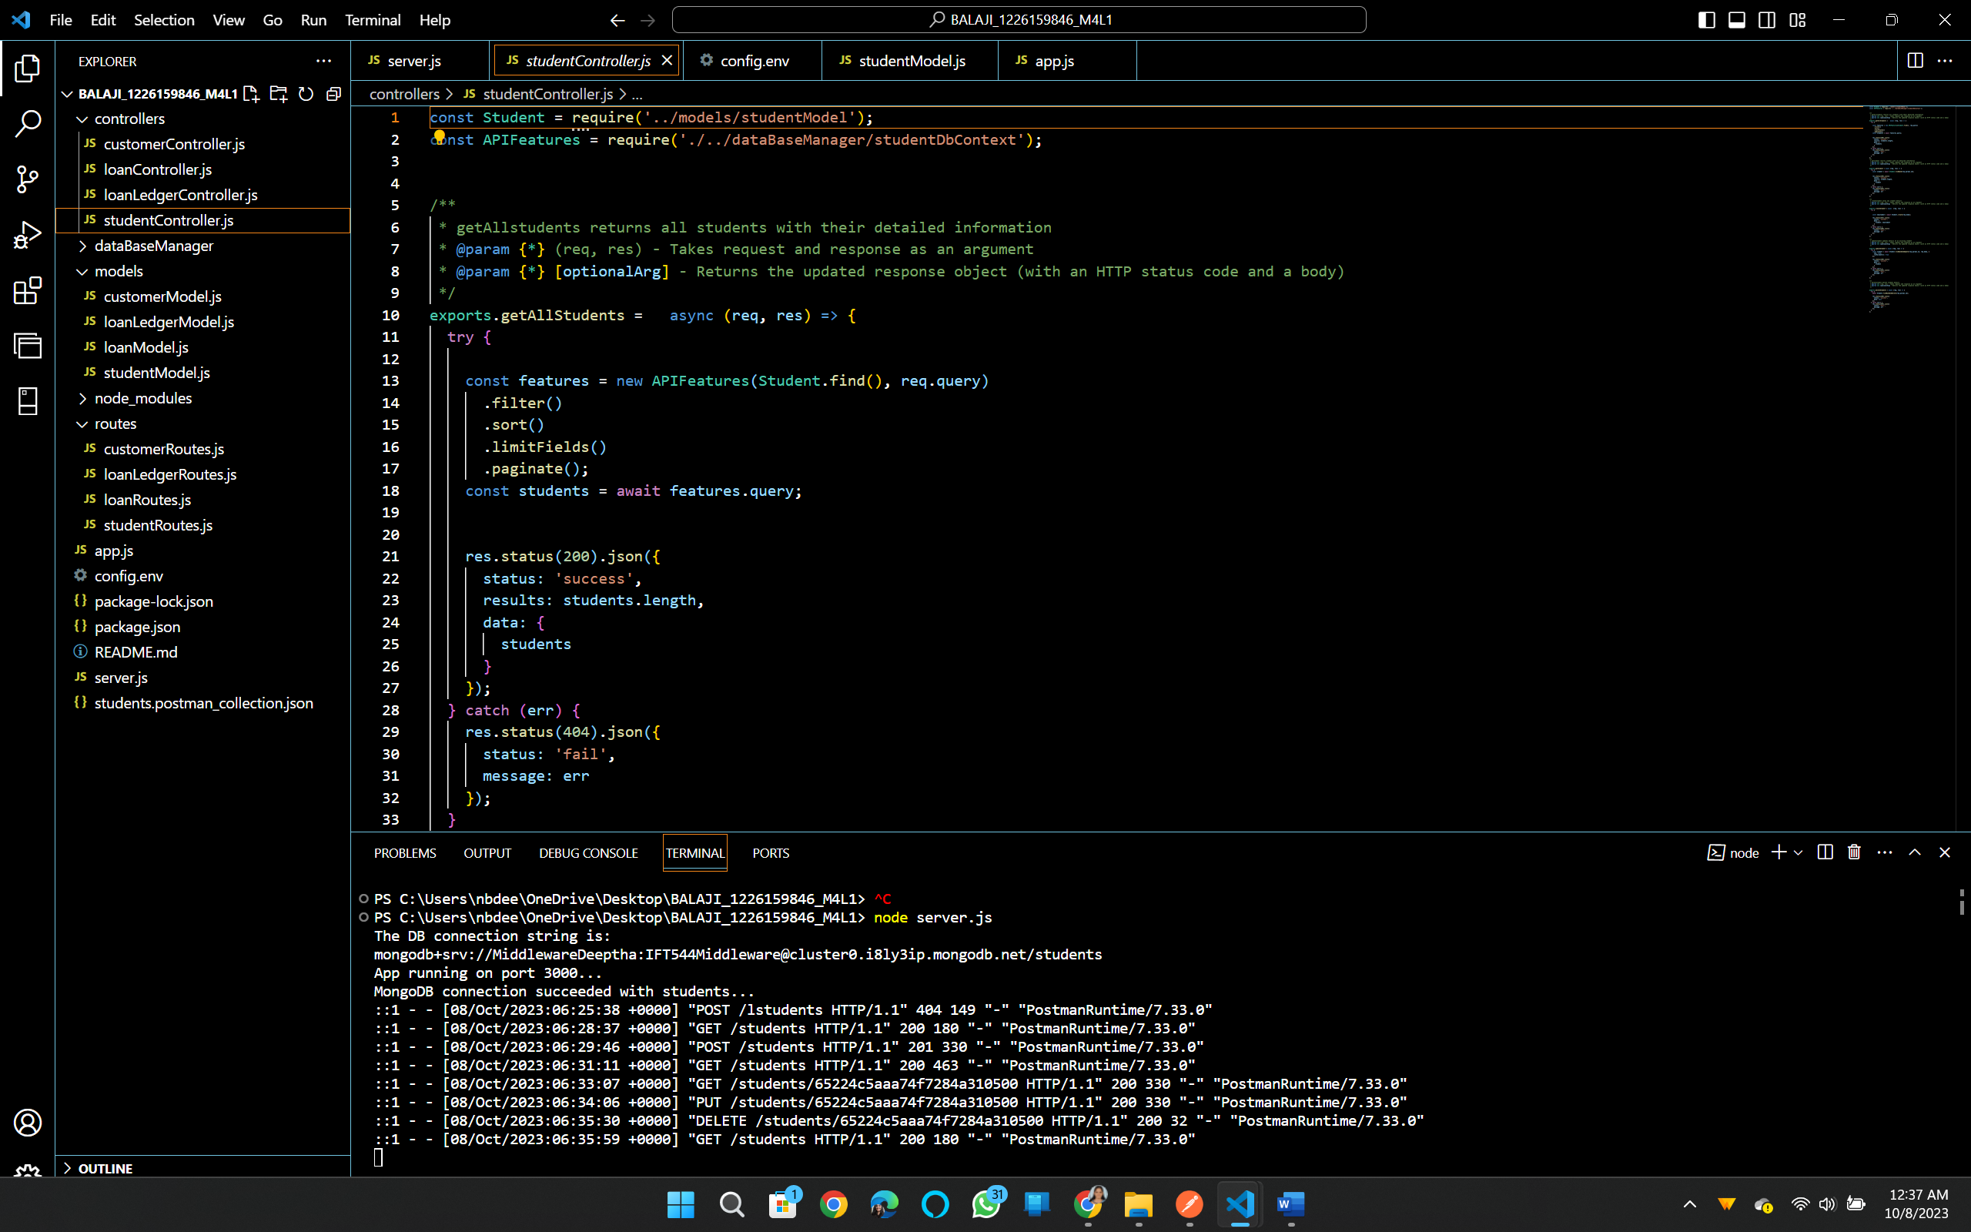

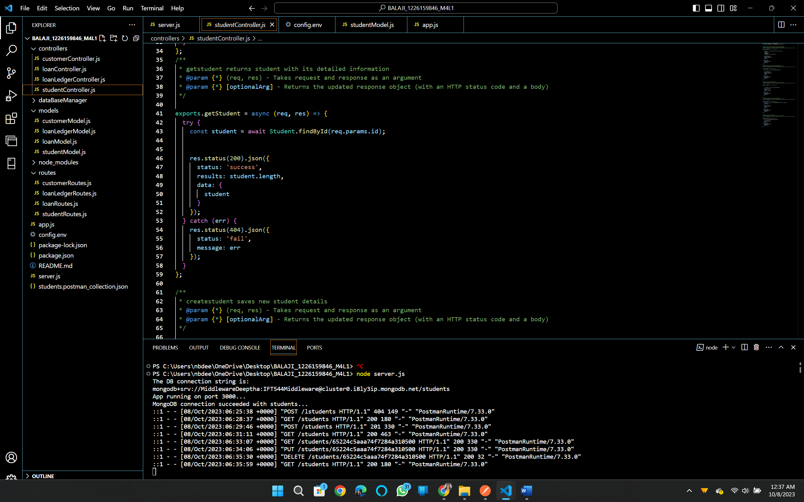

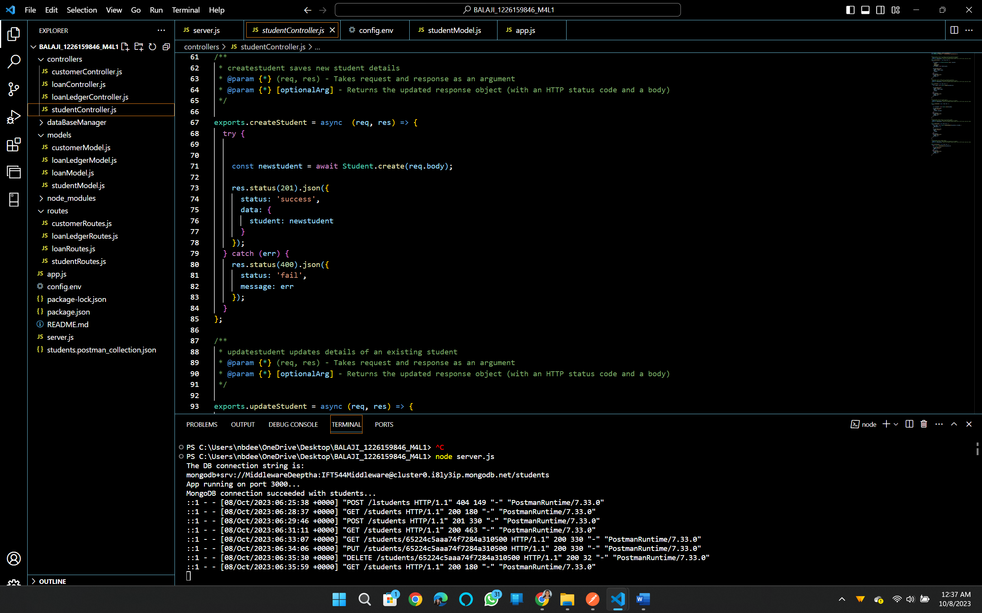

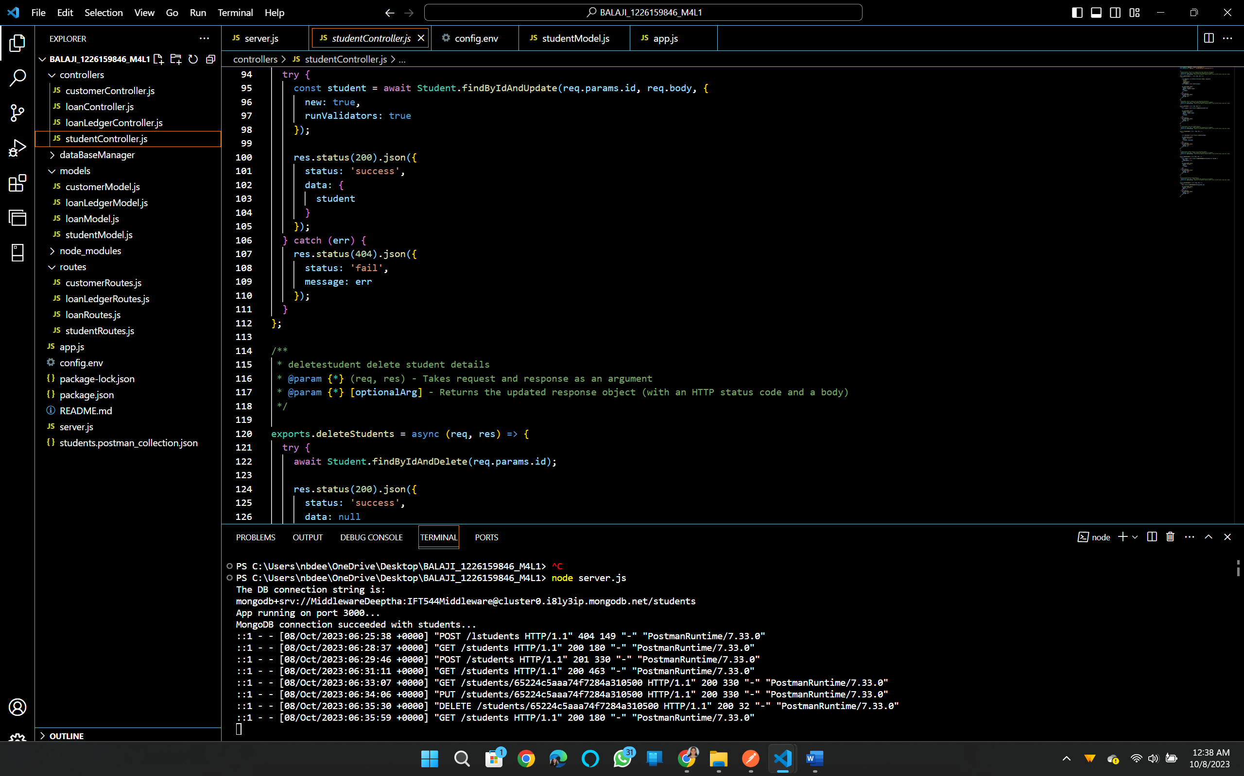

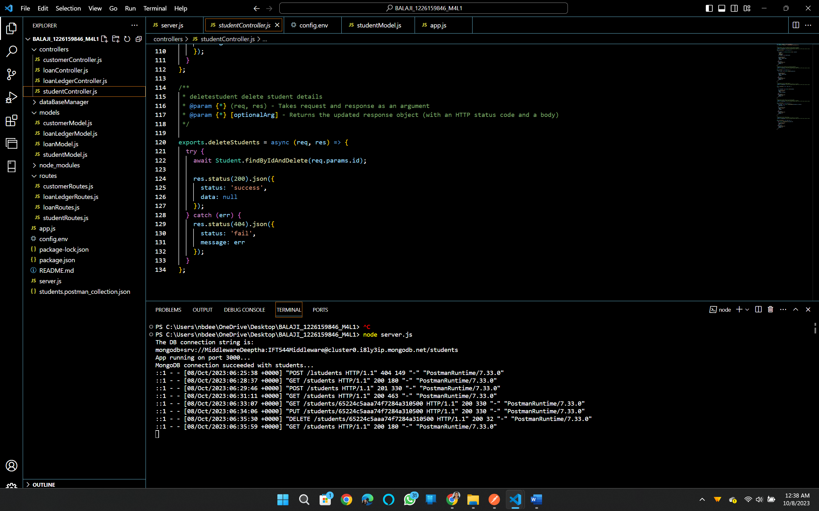

**Student route:**

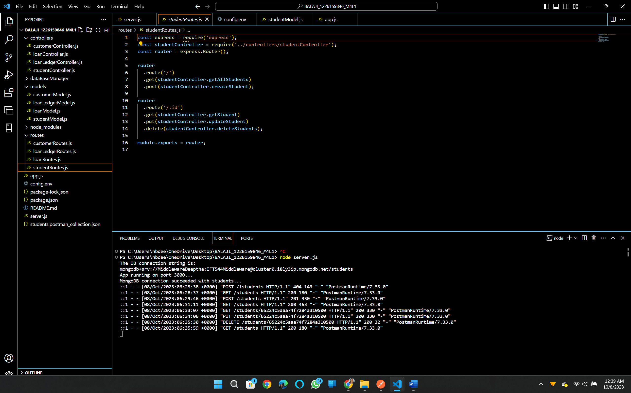

**Db context:**

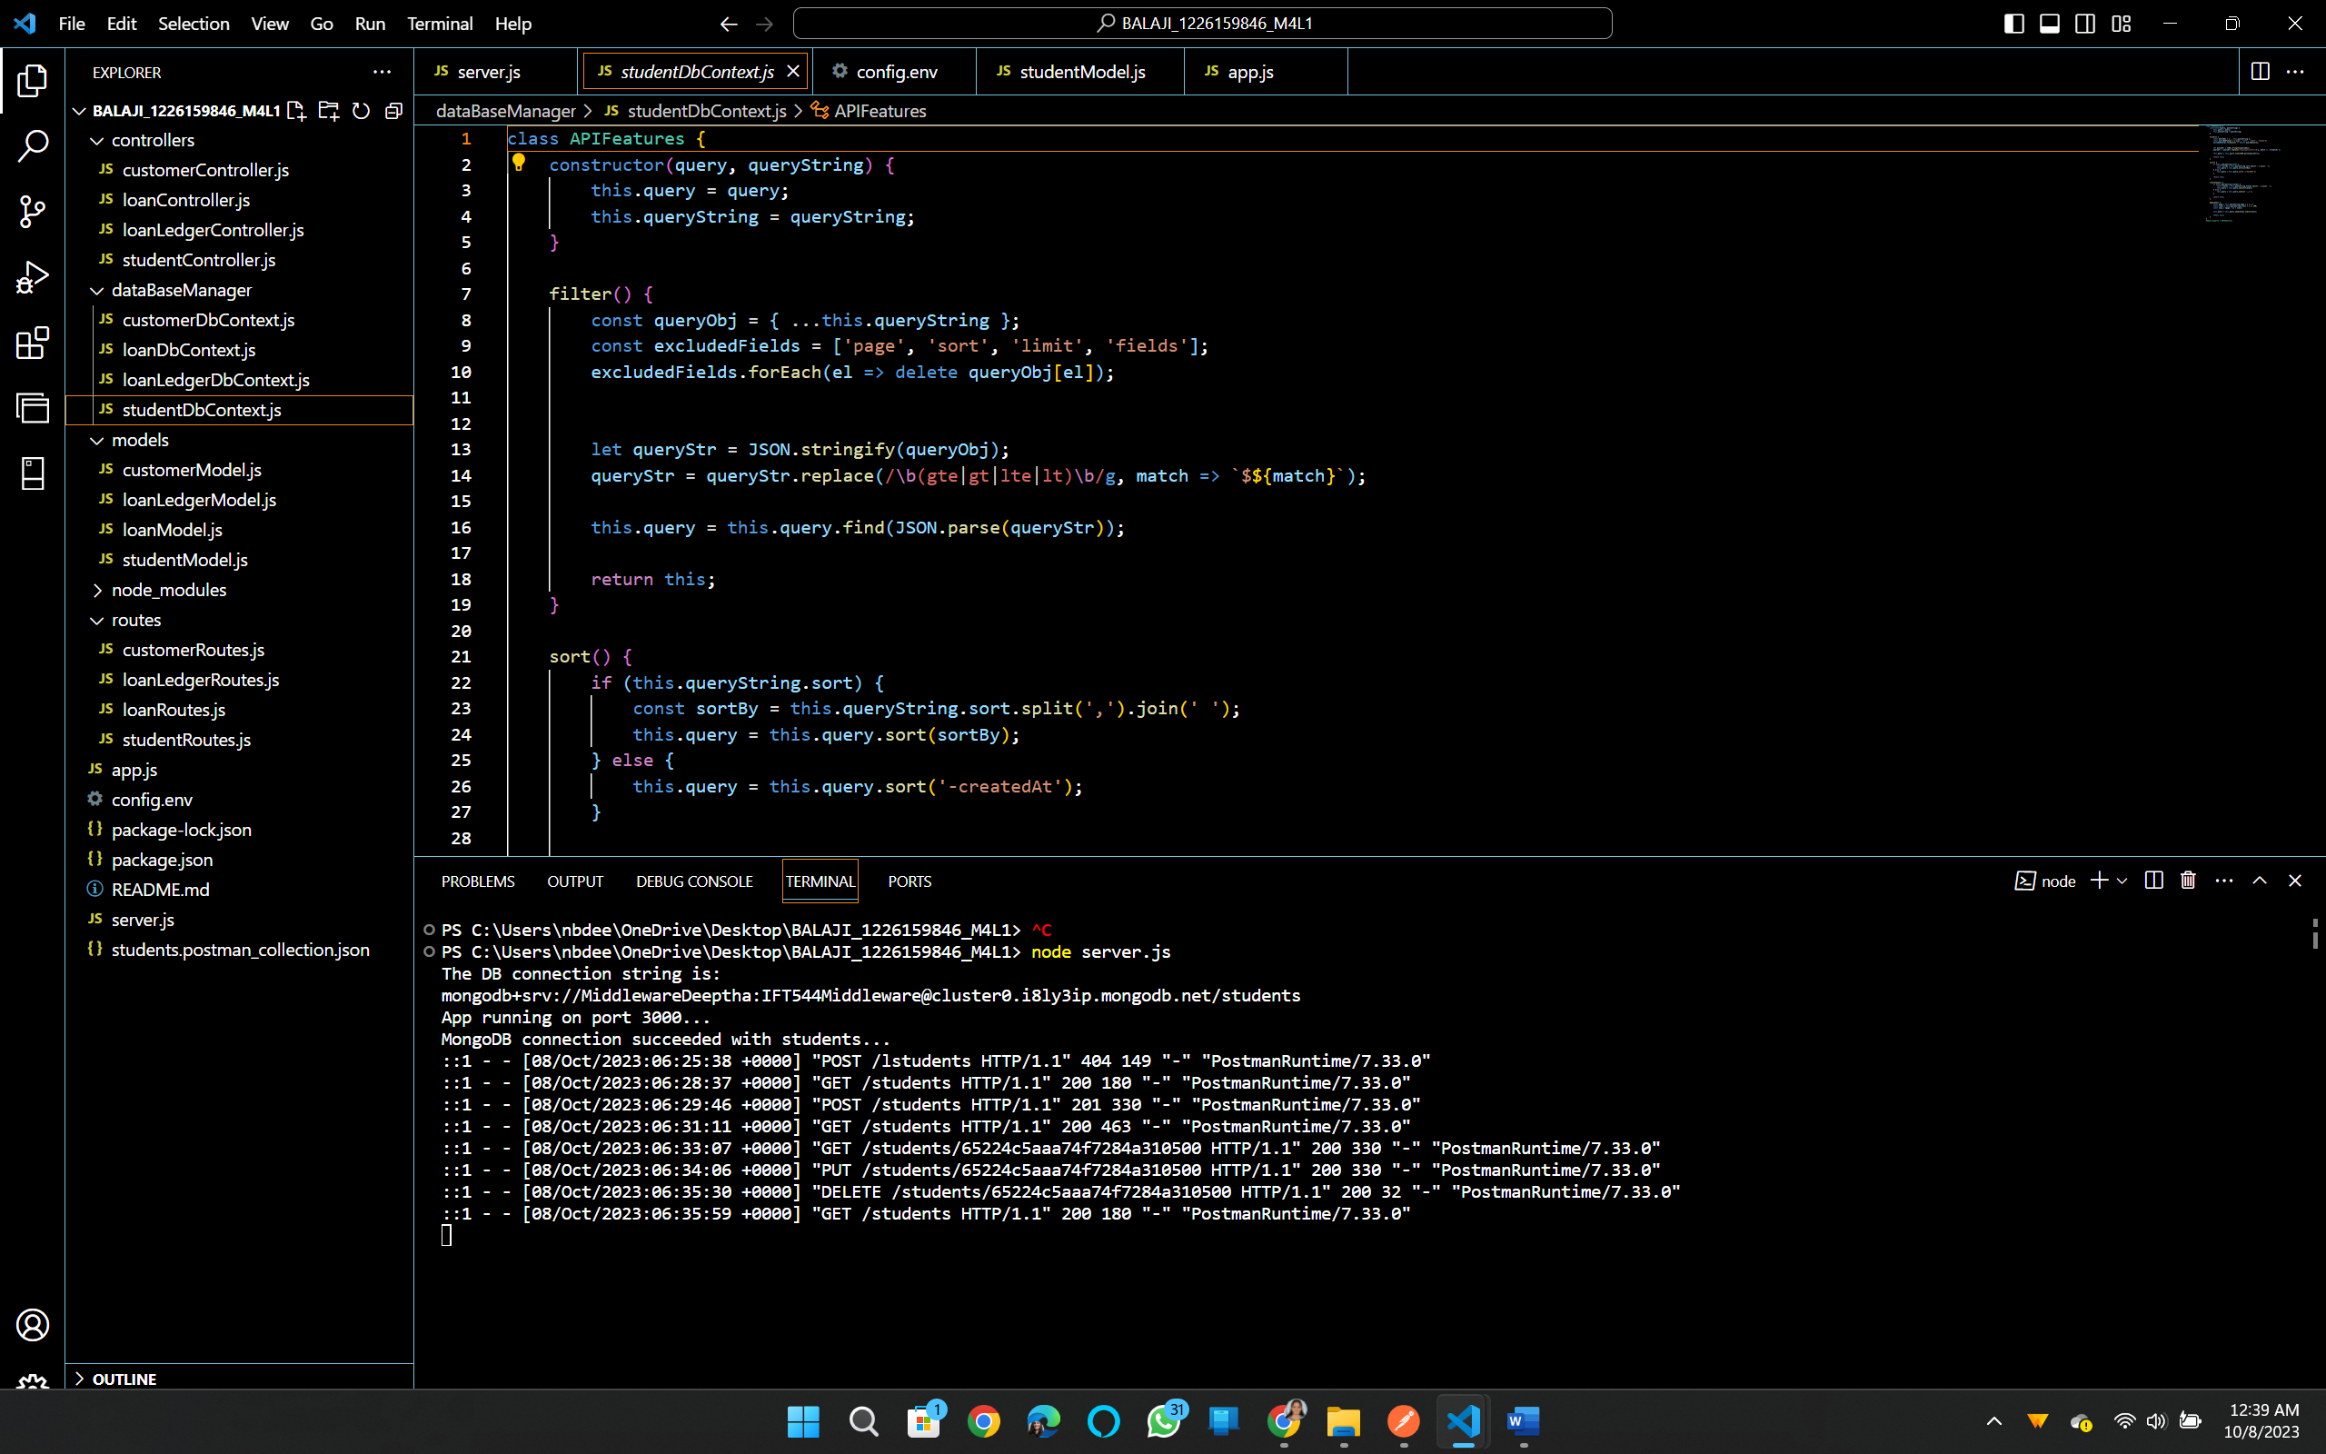

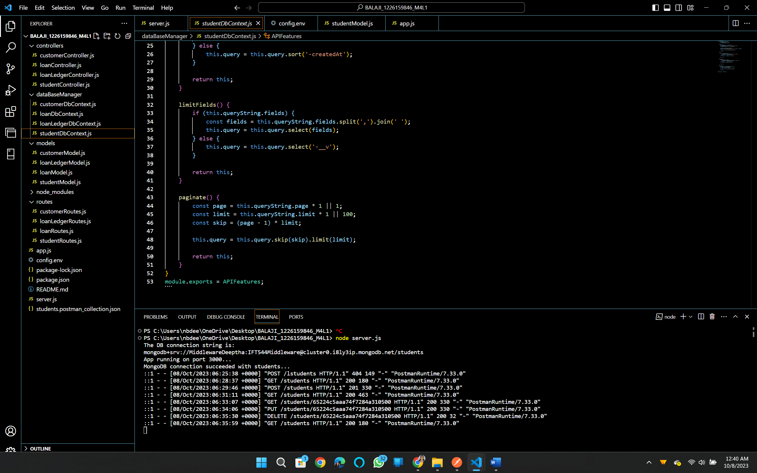

**Github:** [**https://github.com/DeepthaBalaji/MODULE-4-LAB-1-DEEPTHA**](https://github.com/DeepthaBalaji/MODULE-4-LAB-1-DEEPTHA)

